From ChatGPT to Autonomous Agents: A Systematic Literature Review and Bibliometric Analysis of Agentic Artificial Intelligence in Organizations
Bogdan Costache
Bucharest University of Economic Studies
Vladimir Aurelian Enachescu
Bucharest University of Economic Studies
Costin Petcu
"Carol Davila"University of Medicine and Pharmacy, Bucharest

ABSTRACT: The rapid diffusion of generative artificial intelligence has altered the technological and organizational landscape, shifting scholarly and managerial attention from systems primarily designed to generate content toward increasingly autonomous systems capable of planning, reasoning, coordinating actions, and pursuing goals with limited human intervention. This transition has given rise to the concept of agentic artificial intelligence, a broad category encompassing autonomous agents, multi-agent systems, and emerging forms of AI-enabled organizational actors. Despite growing academic and practitioner interest, the literature remains fragmented across computer science, information systems, management, and organizational studies, with limited conceptual integration regarding the implications of agentic AI for organizational design, governance, and leadership.
This study addresses this fragmentation through a systematic literature review and bibliometric analysis of the emerging research domain of agentic artificial intelligence in organizations. Following PRISMA guidelines, the study employs a structured search strategy using the Scopus and Web of Science databases and applies performance analysis and science-mapping techniques through Bibliometrix and VOSviewer. The analysis identifies the principal intellectual foundations of the field, the most influential authors, journals, and countries, and the thematic trajectories that have shaped scholarly discussions from early research on autonomous agents and multi-agent systems to contemporary debates on AI governance and organizational transformation.
The findings reveal a significant shift from technical investigations of autonomous systems toward questions concerning organizational decision-making, human-agent collaboration, governance mechanisms, and the strategic implications of increasingly autonomous AI systems. Six major research themes emerge from the literature: autonomous decision-making systems, multi-agent collaboration, agentic AI governance, human-agent interaction, organizational transformation and leadership, and ethical and societal risks. Building on these findings, the article develops an Agentic AI Organizational Transformation Framework that conceptualizes agentic AI as a dynamic organizational capability whose outcomes depend on governance arrangements, organizational readiness, and institutional trust.
The study contributes to the literature in three ways. First, it provides the first integrative mapping of agentic artificial intelligence research from an organizational perspective. Second, it advances a conceptual framework linking agentic AI capabilities to organizational outcomes and governance mechanisms. Third, it develops a future research agenda aimed at supporting empirical investigations of autonomous AI systems in complex organizational environments. The article concludes that agentic artificial intelligence should not be viewed merely as an incremental extension of generative AI but rather as a potentially transformative organizational phenomenon that may redefine decision-making processes, leadership practices, and the boundaries between human and artificial agency.

KEYWORDS: Agentic Artificial Intelligence; Autonomous Agents; Artificial Intelligence Governance; Organizational Transformation; Large Language Models; Multi-Agent Systems; Human-AI Collaboration; Bibliometric Analysis; Systematic Literature Review; Organizational Decision-Making.

1. Introduction
The public release of large language models and conversational systems such as ChatGPT marked a turning point in the diffusion of artificial intelligence. Within a relatively short period, generative AI moved from being a specialized technological capability to a mainstream organizational resource adopted across industries, educational institutions, and public administrations. Yet the pace of technological development did not stop with systems capable of generating text, images, and software code. Increasingly, researchers and technology firms are pursuing a more ambitious objective - the development of artificial intelligence systems capable of autonomous reasoning, planning, coordination, and action execution. These emerging systems, often described as agentic artificial intelligence, are designed not merely to answer questions but to pursue goals, interact with digital environments, collaborate with other agents, and adapt their behavior over time.
This transition represents more than a technical evolution. It potentially alters fundamental assumptions concerning organizational decision-making, the allocation of authority, and the relationship between human and artificial agency. Historically, information systems have been conceived as decision-support technologies intended to augment human cognition and improve organizational efficiency. Agentic AI introduces a qualitatively different possibility. Autonomous agents may increasingly participate in strategic processes, execute complex workflows, coordinate organizational resources, and make recommendations that directly shape organizational outcomes. Consequently, organizations may need to reconsider not only how technology is implemented but also how governance structures, accountability mechanisms, and leadership practices are designed.
The concept of autonomous agents is by no means new. Research on intelligent agents and multi-agent systems emerged more than three decades ago within artificial intelligence and computer science, producing substantial contributions to distributed problem solving, adaptive systems, and computational coordination (Wooldridge & Jennings, 1995; Wooldridge, 2009). Early studies largely focused on technical questions concerning architecture, communication protocols, and computational efficiency. However, recent advances in large language models and generative AI have dramatically expanded the practical capabilities of autonomous agents, allowing them to operate in increasingly unstructured environments and perform tasks previously considered to require uniquely human cognitive abilities (Bommasani et al., 2021; Park et al., 2023).
The emergence of generative agents and autonomous AI systems has therefore stimulated a new wave of interdisciplinary interest extending well beyond computer science. Management scholars, organizational theorists, information systems researchers, and public policy specialists have begun to examine how these technologies may reshape organizations and institutions (Davenport & Mittal, 2022; Dwivedi et al., 2023; Brynjolfsson et al., 2025). Questions that were once largely hypothetical have become increasingly practical. Can autonomous agents participate in managerial decision-making? What forms of governance are necessary when AI systems possess substantial operational autonomy? How should organizations distribute accountability between human actors and artificial agents? Can autonomous systems become organizational actors in their own right?
These questions emerge at a time when organizations are already operating under conditions of heightened uncertainty and complexity. Global supply-chain disruptions, geopolitical instability, regulatory fragmentation, demographic transitions, and rapid technological change have collectively increased the importance of organizational adaptability and resilience. In such environments, organizations increasingly seek technologies capable of processing large amounts of information, coordinating distributed activities, and supporting strategic responses under conditions of ambiguity (Teece, 2018). Agentic AI appears particularly attractive in this regard because its promise extends beyond automation toward forms of adaptive and semi-autonomous organizational intelligence.
At the same time, the growing autonomy of artificial intelligence systems raises significant concerns. Existing governance frameworks for artificial intelligence have primarily been developed around predictive models and generative systems, emphasizing transparency, fairness, accountability, and explainability (Floridi et al., 2018; Jobin et al., 2019; Taeihagh, 2021). Agentic AI may challenge many of these assumptions. Autonomous agents can pursue objectives, interact with other agents, generate emergent behaviors, and adapt dynamically to changing environments. Such characteristics complicate questions of control, responsibility, and ethical oversight. The possibility of multi-agent ecosystems operating with limited human intervention introduces novel forms of organizational and societal risk that remain poorly understood.
Despite the rapidly expanding interest in autonomous AI systems, the scholarly literature remains fragmented. Research relevant to agentic AI is dispersed across several domains, including artificial intelligence, robotics, information systems, strategic management, human-computer interaction, and organizational studies. Different terminologies are frequently employed, including autonomous agents, intelligent agents, AI agents, generative agents, autonomous systems, and multi-agent systems. Consequently, there is currently no consolidated understanding of how this literature has evolved, what intellectual traditions have shaped it, or how the field is converging around questions of organizational transformation and governance.
This fragmentation is particularly evident when examining the organizational implications of agentic AI. Existing reviews have predominantly focused on technical developments in artificial intelligence, the societal implications of generative AI, or the ethics of algorithmic decision-making. Comparatively little attention has been devoted to understanding agentic AI as an organizational phenomenon that may reshape governance structures, redefine leadership roles, and alter the boundaries between human and machine agency. The absence of integrative frameworks makes it difficult for scholars and practitioners to assess the transformative potential of these technologies or identify the conditions under which their adoption may contribute to organizational performance and resilience.
Against this backdrop, the present study seeks to provide a comprehensive and systematic assessment of the emerging literature on agentic artificial intelligence in organizations. The article adopts a dual methodological approach that combines systematic literature review techniques with bibliometric analysis. Systematic reviews provide conceptual depth and allow the identification of thematic patterns and theoretical developments, while bibliometric methods facilitate the mapping of intellectual structures, collaboration networks, and research trajectories (Donthu et al., 2021; Zupic & Čater, 2015). The integration of these approaches is particularly suitable for rapidly evolving fields characterized by conceptual fragmentation and interdisciplinary dispersion.
The study addresses four interrelated research questions:
RQ1: How has research on agentic artificial intelligence evolved over time?
RQ2: What are the principal intellectual and conceptual foundations of the field?
RQ3: What thematic structures and emerging research directions characterize the literature on agentic AI in organizations?
RQ4: How might agentic artificial intelligence transform organizational governance, leadership, and decision-making processes?
Addressing these questions is important for several reasons. First, agentic AI appears poised to become one of the defining technological developments of the coming decade. While generative AI has already transformed knowledge work, autonomous agents may fundamentally alter the architecture of organizations themselves. Second, organizations are increasingly experimenting with AI agents capable of managing workflows, coordinating information, and performing tasks that were traditionally executed by employees or managers. Third, policymakers and regulators are beginning to recognize that highly autonomous systems may require new governance frameworks that extend beyond current approaches to AI regulation.
This article therefore aims to make three principal contributions to the literature.
The first contribution is descriptive and integrative. By combining systematic review methods and bibliometric techniques, the study provides the first comprehensive mapping of the intellectual landscape surrounding agentic artificial intelligence in organizational contexts. It identifies the most influential journals, authors, countries, and research streams that have shaped the development of the field.
The second contribution is conceptual. The article synthesizes the fragmented literature into six major thematic domains that collectively capture the evolution of scholarly thinking regarding autonomous AI systems in organizations. These themes provide a structured understanding of how the literature has progressed from technical considerations toward broader questions of governance, organizational transformation, and human-AI collaboration.
The third contribution is theoretical and prospective. Building upon the findings of the bibliometric and systematic analyses, the article develops an Agentic AI Organizational Transformation Framework that conceptualizes agentic AI as a dynamic organizational capability whose effects are contingent upon governance mechanisms, digital maturity, leadership support, and institutional trust. The framework also generates propositions and identifies promising avenues for future empirical investigation.
The argument developed throughout this article is relatively straightforward but carries significant implications. Agentic artificial intelligence should not be understood as merely another stage in the progression of generative AI technologies. Rather, it represents the emergence of increasingly autonomous socio-technical actors capable of participating in organizational processes in fundamentally new ways. Whether these developments lead to improved organizational performance, enhanced resilience, and more effective decision-making, or instead generate new forms of risk, inequality, and governance failure, will depend largely on the institutional arrangements and organizational capabilities that accompany their deployment.
The sections that follow examine this emerging field through a systematic and bibliometric lens. The next section reviews the theoretical foundations of agentic artificial intelligence and situates the phenomenon within broader debates concerning organizational theory, governance, and socio-technical systems. Subsequent sections present the methodological approach, analyze the intellectual and conceptual structures of the field, and develop a future-oriented framework for understanding the role of autonomous agents in organizations.

2. Literature Review

2.1 The Evolution of Artificial Intelligence: From Rule-Based Systems to Agentic Intelligence
The history of artificial intelligence can be interpreted as a sequence of progressively expanding conceptions of machine capability. Early artificial intelligence research in the 1950s and 1960s was largely concerned with symbolic reasoning and the possibility of reproducing human intelligence through formal rules and logical inference (Russell & Norvig, 2021). The prevailing assumption was that intelligence could be encoded explicitly and that computational systems could solve complex problems through symbolic manipulation. Expert systems developed during the 1980s represented the most mature expression of this paradigm, offering organizations the possibility of embedding specialist knowledge into computational decision-support systems.
Despite their initial promise, rule-based systems suffered from significant limitations. They performed poorly in uncertain environments, struggled to generalize across contexts, and required substantial manual intervention to update knowledge bases. These constraints gradually encouraged a shift toward data-driven approaches, particularly machine learning techniques capable of identifying patterns and making predictions without explicit programming (Jordan & Mitchell, 2015).
The rise of machine learning fundamentally changed both the scientific and organizational understanding of artificial intelligence. Rather than focusing on codified rules, researchers increasingly emphasized statistical learning, predictive modeling, and computational adaptation. The subsequent emergence of deep learning further accelerated this transition, enabling unprecedented advances in computer vision, natural language processing, and speech recognition (LeCun, Bengio, & Hinton, 2015). Organizations rapidly adopted these technologies for applications ranging from customer analytics and predictive maintenance to fraud detection and recommendation systems.
The arrival of foundation models and generative artificial intelligence represents the latest phase in this historical evolution. Large language models such as GPT, Claude, Gemini, and Llama have demonstrated capabilities that extend far beyond prediction and classification. These systems can generate sophisticated textual outputs, summarize complex information, write computer code, and engage in natural language interactions that approximate human communication (Bommasani et al., 2021; OpenAI, 2023). Their rapid adoption has prompted widespread discussions concerning the future of work, productivity, and organizational transformation (Brynjolfsson, Li, & Raymond, 2023).
Yet even generative AI may represent only an intermediate stage in the evolution of intelligent systems. Increasingly, researchers and practitioners are focusing their attention on artificial intelligence systems capable not merely of generating outputs but of pursuing objectives, coordinating actions, and interacting autonomously with digital environments. These developments have contributed to the emergence of what is now commonly referred to as agentic artificial intelligence.
Unlike traditional AI systems that respond to predefined inputs or generate outputs based on prompts, agentic systems are characterized by varying degrees of autonomy, environmental awareness, memory, planning capability, and goal-directed behavior. Such systems may interact with other agents, adapt their strategies over time, and perform sequences of actions with limited human supervision (Park et al., 2023; Xi et al., 2023). Figure 1 illustrates this evolutionary trajectory.

Figure 1. Evolutionary Trajectory of Artificial Intelligence Toward Agentic Systems
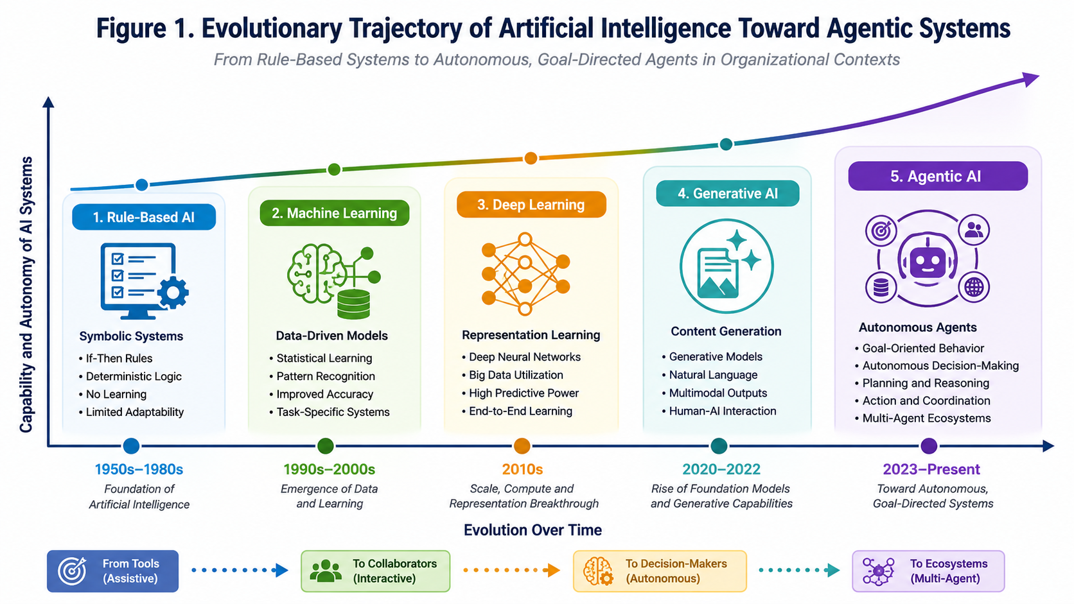
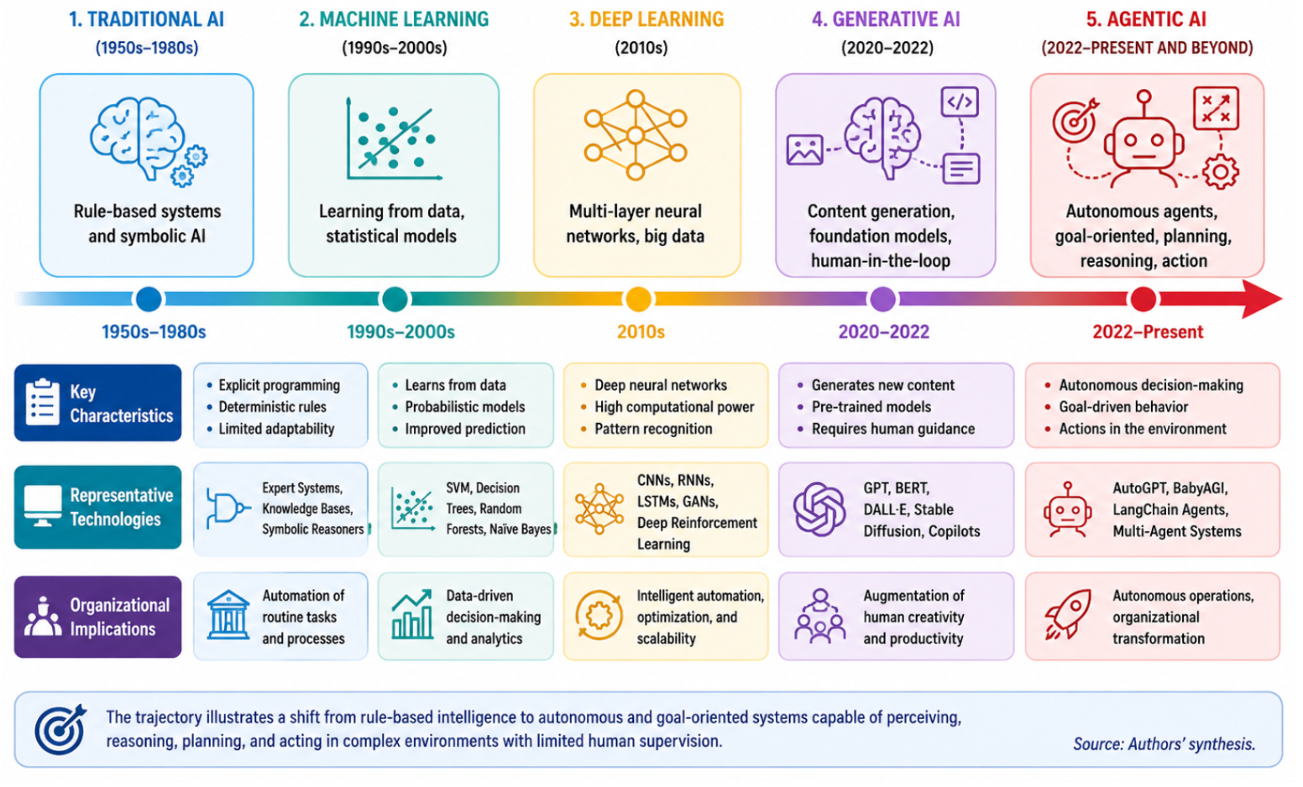
Source: Authors' conceptual representation based on Russell and Norvig (2021), Bommasani et al. (2021), Park et al. (2023), and Xi et al. (2023).
The figure suggests that the development of artificial intelligence can be understood not simply as a sequence of technological improvements but as a gradual expansion of machine autonomy. Whereas earlier forms of AI primarily supported human decision-making, agentic systems increasingly possess the capacity to initiate actions and participate directly in organizational processes.
This transition raises important theoretical and practical questions. If organizations are increasingly populated by semi-autonomous or fully autonomous agents, traditional assumptions concerning organizational structure, leadership, and governance may require substantial revision.

2.2 Defining Agentic Artificial Intelligence
Although the term "agentic artificial intelligence" has recently gained considerable visibility, the underlying concept draws upon a long tradition of research on intelligent agents and multi-agent systems. Wooldridge and Jennings (1995, p. 116) define an intelligent agent as:
"a computer system that is situated in some environment and that is capable of autonomous action in this environment in order to meet its design objectives."
This definition highlights several characteristics that remain central to contemporary understandings of agentic AI:
- autonomy;
- situatedness;
- goal orientation;
- environmental interaction;
- adaptive behavior.
Agentic AI extends these characteristics by integrating the capabilities of large language models, advanced reasoning architectures, memory systems, and planning mechanisms into autonomous agents capable of executing complex tasks.
Recent studies describe agentic AI systems as technologies capable of:
- formulating objectives;
- decomposing problems;
- planning sequences of actions;
- interacting with tools and external environments;
- learning from feedback;
- coordinating with other agents.
Park et al. (2023) demonstrated that generative agents equipped with memory and planning capabilities can exhibit remarkably sophisticated behaviors, including social interaction and adaptive decision-making. Similarly, Xi et al. (2023) argue that large language model agents represent a fundamental shift from conversational AI toward autonomous cognitive systems capable of sustained and purposeful activity. Several dimensions distinguish agentic AI from previous forms of artificial intelligence.

Autonomy Agentic systems possess the ability to initiate actions without continuous human prompting. Autonomy does not imply complete independence from human oversight, but it does involve substantial discretion in determining how objectives are achieved.

Goal Orientation: Unlike generative models that respond to isolated prompts, agentic systems pursue longer-term objectives and can decompose complex goals into multiple subtasks.

Environmental Interaction Agentic systems can interact with external environments through software interfaces, databases, and digital platforms, thereby extending their influence beyond information generation.

Memory and Learning Many contemporary agents maintain persistent memory structures that allow them to learn from previous interactions and adapt their behavior over time (Park et al., 2023).

Multi-Agent Coordination Perhaps the most distinctive feature of agentic AI is the possibility of collaboration among multiple autonomous agents. Such ecosystems may involve specialized agents that communicate, negotiate, and coordinate activities to achieve complex objectives.
Table 1 summarizes the principal characteristics of agentic artificial intelligence.

Table 1. Defining Characteristics of Agentic Artificial Intelligence
Dimension | Traditional AI | Generative AI | Agentic AI
Primary Function | Prediction | Content Generation | Goal Execution
Decision Autonomy | Low | Low to Moderate | High
Memory | Limited | Session-Based | Persistent
Planning Capability | Minimal | Limited | Extensive
Environmental Interaction | Restricted | Restricted | Active
Learning Mechanism | Model Retraining | Prompt Adaptation | Continuous Adaptation
Collaboration | None | Human-AI | Human-AI and Multi-Agent
Organizational Role | Support Tool | Productivity Assistant | Semi-Autonomous Organizational Actor
Accountability Complexity | Low | Moderate | High
Governance Requirements | Technical | Ethical | Socio-Technical and Institutional

Source: Authors' synthesis based on Wooldridge and Jennings (1995), Russell and Norvig (2021), Park et al. (2023), and Xi et al. (2023).
The growing autonomy of these systems suggests that agentic AI should be examined not merely as a technological artifact but as an emerging organizational phenomenon.

2.3 Agentic Artificial Intelligence and Organizations
Organizations have historically incorporated technological innovations in ways that augment existing capabilities while preserving established governance structures. Information systems have generally been designed to improve efficiency, facilitate communication, or support managerial decision-making.
Agentic AI may challenge this pattern.: Autonomous agents possess characteristics that potentially alter organizational boundaries, redistribute authority, and reshape relationships between human actors and technological systems. Consequently, agentic AI increasingly occupies a central position in discussions concerning organizational transformation and digital strategy.
Several areas of organizational activity appear particularly susceptible to transformation.

Strategic Decision-Making - AI agents can analyze large quantities of information, identify patterns, and generate strategic alternatives. Their ability to process information continuously may substantially improve organizational responsiveness under conditions of uncertainty.

Workflow Automation - Unlike traditional automation technologies that perform narrowly defined tasks, autonomous agents can coordinate multiple activities and adapt dynamically to changing conditions.

Knowledge Management - Organizations increasingly depend upon knowledge-intensive activities requiring information integration and interpretation. Agentic systems may support knowledge discovery, organizational learning, and decision coordination.

Organizational Coordination - Multi-agent systems can coordinate distributed activities and facilitate communication among organizational units. Such capabilities are particularly valuable in complex and geographically dispersed organizations.

Innovation Management - Agentic AI may accelerate innovation by supporting experimentation, generating novel combinations of knowledge, and facilitating organizational learning.
At the same time, these developments create significant governance challenges. Organizations must address questions concerning accountability, transparency, and control when autonomous systems increasingly participate in decision-making processes.
Davenport and Mittal (2022) argue that generative AI may substantially alter organizational structures and work processes, but they also caution that organizations require new forms of governance to manage these technologies effectively. Similar concerns have been raised regarding agentic AI, where the degree of autonomy may exceed the assumptions embedded within existing regulatory and managerial frameworks. The organizational implications of agentic AI therefore extend beyond productivity gains. They concern the very architecture of organizations and the future relationship between human and artificial agency.

2.4 Agentic Artificial Intelligence versus Generative Artificial Intelligence
The rapid success of ChatGPT and similar systems has created a tendency to treat all contemporary AI developments as extensions of generative AI. Such an interpretation risks obscuring important conceptual differences.
Generative AI and agentic AI represent distinct paradigms.
Generative systems primarily create content in response to prompts, whereas agentic systems pursue objectives and execute actions. The distinction is subtle but significant. Generative AI functions primarily as an assistant, while agentic AI increasingly resembles an autonomous organizational participant.
Table 2 highlights these differences.

Table 2. Agentic Artificial Intelligence versus Generative Artificial Intelligence
Dimension | Generative AI | Agentic AI
Core Function | Content Generation | Goal Execution
User Interaction | Prompt-Based | Objective-Based
Autonomy | Low | High
Planning | Minimal | Extensive
Memory | Context Window | Persistent and Adaptive
Decision-Making | Human-Led | Shared or Autonomous
Environmental Interaction | Limited | Active
Coordination | Individual System | Multi-Agent Ecosystems
Organizational Role | Assistant | Organizational Actor
Governance Complexity | Moderate | High
Accountability | Primarily Human | Distributed
Strategic Implications | Productivity Gains | Organizational Transformation

Source: Authors' synthesis.
The transition from generative systems to autonomous agents therefore represents a shift from augmentation toward delegation. This distinction has profound implications for organizational theory and governance.

2.5 Theoretical Lenses for Understanding Agentic Artificial Intelligence in Organizations
Because agentic AI sits at the intersection of technology and organization, no single theoretical perspective appears sufficient to explain its implications. The literature instead draws upon multiple complementary frameworks.

Complexity Theory - Organizations increasingly operate within complex adaptive systems characterized by interdependence, emergence, and nonlinearity (Uhl-Bien & Arena, 2018). Agentic AI introduces additional sources of complexity because autonomous agents interact dynamically with both human actors and other agents.
Complexity theory therefore provides an appropriate lens for understanding emergent behaviors and unintended consequences within multi-agent organizational ecosystems.

Socio-Technical Systems Theory - Socio-technical theory emphasizes the joint optimization of technological and social subsystems (Trist & Bamforth, 1951). Agentic AI systems cannot be understood solely through their technical characteristics because their effects depend upon organizational structures, governance mechanisms, and human practices.

Dynamic Capabilities Theory - Teece (2018) conceptualizes dynamic capabilities as the ability of organizations to sense opportunities, seize them, and transform organizational resources. Agentic AI may constitute a dynamic capability that improves organizational adaptability and strategic responsiveness.

Organizational Information Processing Theory - Galbraith (1974) argues that organizations exist to process information under conditions of uncertainty. Autonomous agents substantially expand information-processing capacity and may fundamentally alter organizational mechanisms for dealing with complexity.

Agency Theory - Traditional agency theory assumes that decision authority resides primarily in human actors. Agentic AI challenges this assumption by introducing forms of distributed and hybrid agency in which decisions increasingly emerge through interactions between humans and autonomous systems.

Human-AI Collaboration Theory - Recent research emphasizes that artificial intelligence should be understood not merely as a substitute for human labor but as a collaborative partner capable of augmenting human capabilities (Dellermann et al., 2019). Agentic AI intensifies these debates because collaboration increasingly occurs between humans and systems possessing significant autonomy.
Figure 2 integrates these theoretical perspectives.

Figure 2. Multi-Theoretical Foundations of Agentic Artificial Intelligence in Organizations
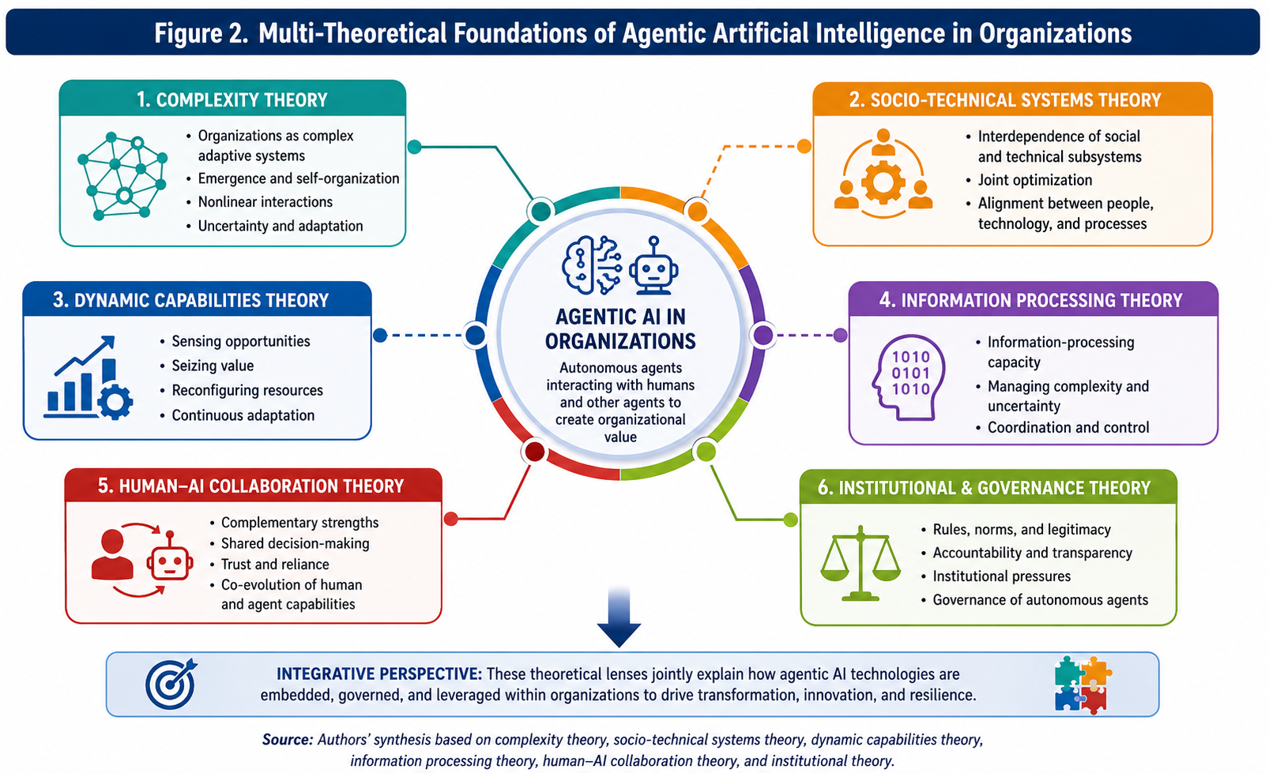
Source: Authors' conceptual framework.
Taken together, these theoretical lenses suggest that agentic artificial intelligence should be understood as an emerging socio-technical phenomenon whose implications extend far beyond technological innovation. Autonomous agents may eventually become embedded within organizational structures in ways that alter decision-making processes, governance arrangements, and conceptions of organizational agency itself.
The next section explains the methodological approach used to map and synthesize this rapidly evolving body of knowledge through a combination of systematic literature review techniques and advanced bibliometric analysis.

3. Methodology

3.1 Research Design
The study adopts an integrated research design combining systematic literature review procedures with advanced bibliometric techniques. The decision to combine these two approaches is grounded in the recognition that the literature on agentic artificial intelligence remains fragmented, rapidly evolving, and dispersed across multiple disciplinary communities. Bibliometric methods are particularly useful when a research field exhibits conceptual ambiguity and accelerated growth because they permit the identification of intellectual structures that remain difficult to observe through conventional narrative reviews alone (Donthu et al., 2021). At the same time, bibliometric analysis, when conducted in isolation, often privileges quantitative patterns at the expense of theoretical interpretation. The integration of systematic review techniques therefore provides the interpretive depth necessary to move beyond descriptive mapping and toward conceptual synthesis.
The methodological architecture of this study follows recent recommendations for high-quality review articles in management and information systems research (Paul & Criado, 2020; Zupic & Čater, 2015). The review process combines performance analysis, science mapping, and thematic synthesis within a sequential mixed-method design. Performance analysis is employed to identify publication trends, influential authors, journals, institutions, and countries. Science mapping techniques are subsequently used to uncover the intellectual, conceptual, and social structures of the field. Finally, a qualitative synthesis of the identified thematic clusters permits the development of an integrative conceptual framework capable of explaining the organizational implications of agentic artificial intelligence.
The choice of this mixed-method design reflects the nature of the research questions. The first two research questions concern the evolution and intellectual structure of the field and therefore require quantitative mapping techniques capable of identifying patterns within large bibliographic datasets. The third and fourth research questions concern emerging themes and organizational implications, requiring interpretive analysis and theoretical abstraction. The combination of bibliometric analysis and systematic review thus permits both breadth and depth, allowing the study to capture the macro-level evolution of the field while simultaneously engaging with the substantive content of the literature. The methodological logic adopted in this article is illustrated in Figure 3.

Figure 3. Integrated Research Design
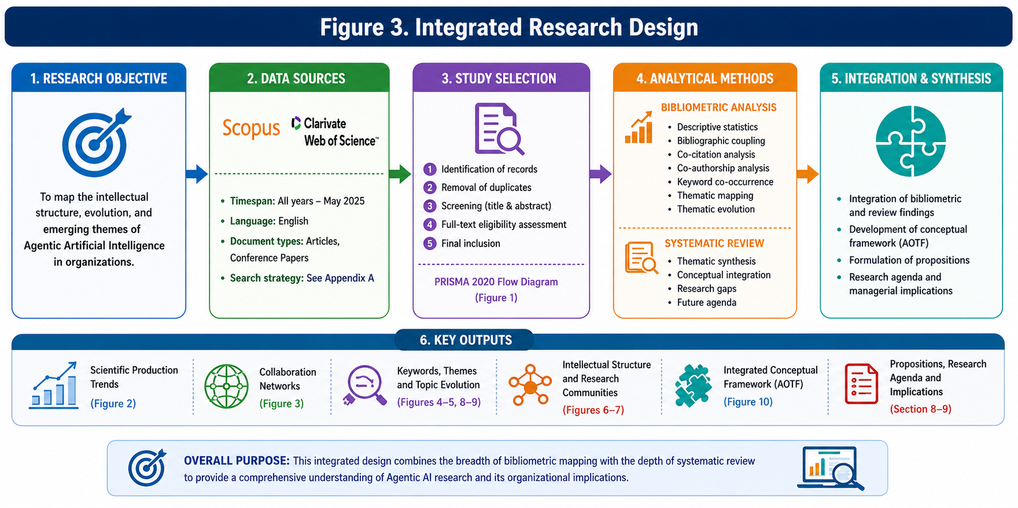
Source: Authors' conceptual representation based on Zupic and Čater (2015) and Donthu et al. (2021).
The figure illustrates the sequential nature of the research design. The process begins with systematic identification and screening procedures and gradually progresses toward increasingly interpretive forms of analysis. Such an approach is particularly suitable for emerging fields where theoretical boundaries remain fluid and where conceptual integration represents a central scholarly objective.

3.2 Data Sources
The bibliographic dataset was constructed using two of the most authoritative multidisciplinary academic databases: Scopus and the Web of Science Core Collection. The decision to rely on these databases is consistent with established practices in bibliometric research within management and information systems scholarship (Donthu et al., 2021; Aria & Cuccurullo, 2017). Both databases maintain rigorous indexing standards, provide comprehensive bibliographic metadata, and offer extensive citation information necessary for advanced science mapping techniques.
Scopus was selected because of its extensive coverage of business, management, computer science, and interdisciplinary journals. Previous studies have demonstrated that Scopus contains a particularly strong representation of emerging technological domains and conference proceedings, which is especially important in rapidly developing fields such as artificial intelligence (Mongeon & Paul-Hus, 2016). The Web of Science Core Collection was included to improve robustness and minimize the risk of database-specific bias. Web of Science remains one of the most influential bibliographic databases and provides high-quality citation indexing that complements Scopus coverage.
The use of both databases increases the comprehensiveness of the dataset and reduces the probability that influential contributions are omitted because of differences in indexing policies or disciplinary orientations. At the same time, combining databases introduces challenges related to duplicate records and metadata inconsistencies. These issues were addressed through systematic cleaning procedures and manual verification processes, thereby improving the reliability of the final dataset.
Because research on agentic artificial intelligence is inherently interdisciplinary, the inclusion of both databases is particularly important. Relevant publications may appear not only in management and information systems journals but also in computer science, engineering, innovation studies, public administration, and organizational research outlets. Restricting the analysis to a single database would therefore risk underrepresenting important intellectual contributions and distorting the structure of the field.

3.3 Search Strategy
The search strategy was developed iteratively and informed by preliminary explorations of the literature, expert consultation, and examination of terminology used in highly cited publications concerning autonomous agents, large language models, and multi-agent systems. One of the principal challenges associated with reviewing this literature is the absence of terminological consensus. The expression "agentic artificial intelligence" has only recently entered academic discourse and is frequently used alongside a variety of related concepts, including autonomous agents, AI agents, generative agents, and large language model agents.
To maximize retrieval while preserving conceptual relevance, the final search string combined several complementary terms:
("agentic artificial intelligence"
OR "agentic AI"
OR "AI agents"
OR "artificial intelligence agents"
OR "autonomous agents"
OR "autonomous artificial intelligence"
OR "generative agents"
OR "LLM agents"
OR "multi-agent systems"
OR "AI agents in organizations")
The search was conducted within titles, abstracts, and keywords. Restricting the search to these fields increases precision by reducing the inclusion of publications where relevant terms appear only incidentally within the full text.
The search process was performed during June 2026. Because the literature on agentic AI is developing rapidly, the search date represents an important methodological parameter and establishes the temporal boundary of the dataset. Future replications of the study may yield larger datasets as publication activity accelerates.
The search strategy intentionally adopts an inclusive approach. Restrictive search expressions may underestimate the size and diversity of emerging research fields, particularly when terminology remains unstable. The inclusion of multiple synonymous expressions therefore increases the likelihood that the review captures the full breadth of scholarly activity related to agentic artificial intelligence.

3.4 Inclusion and Exclusion Criteria
The selection process followed predefined inclusion and exclusion criteria designed to ensure methodological transparency and replicability. Only peer-reviewed journal articles and conference proceedings published in English were included in the final dataset. The focus on peer-reviewed sources reflects the objective of capturing academically validated knowledge and reducing the influence of non-reviewed materials whose scientific rigor may vary substantially.
Publications were included if they satisfied three principal conditions. First, they needed to address autonomous or agentic forms of artificial intelligence as a primary research focus. Second, they had to exhibit relevance for organizational, managerial, governance, or socio-technical contexts. Third, sufficient bibliographic information had to be available to permit bibliometric analysis.
Several categories of publications were excluded. Purely technical engineering studies dealing exclusively with algorithmic optimization or software architecture without organizational implications were omitted because they fell outside the conceptual boundaries of the study. Medical applications, robotics research unrelated to organizational contexts, editorials, book reviews, and non-peer-reviewed materials were also excluded. Duplicate records resulting from database integration were removed during the data cleaning phase.
The inclusion and exclusion procedures were implemented through multiple rounds of screening involving title review, abstract examination, and, when necessary, full-text inspection. Manual verification was considered particularly important because emerging research fields often contain publications whose titles or abstracts provide insufficient information concerning conceptual relevance.

3.5 PRISMA Protocol
To improve methodological rigor and transparency, the study follows the Preferred Reporting Items for Systematic Reviews and Meta-Analyses framework. Although originally developed for evidence synthesis in medical research, PRISMA has increasingly been adopted within management and information systems research because of its systematic and replicable approach to literature identification and selection (Page et al., 2021).
The PRISMA protocol structures the review process into four sequential stages: identification, screening, eligibility assessment, and final inclusion. This procedure provides a transparent account of how the dataset was constructed and allows future researchers to replicate or extend the analysis.
The adoption of PRISMA is particularly important in the context of bibliometric studies because decisions concerning search terms, databases, and exclusion criteria can substantially influence the resulting intellectual maps. Transparent reporting therefore contributes to the credibility and reproducibility of the findings.
Figure 4 presents the PRISMA framework employed in this study.

Figure 4. PRISMA Flow Diagram
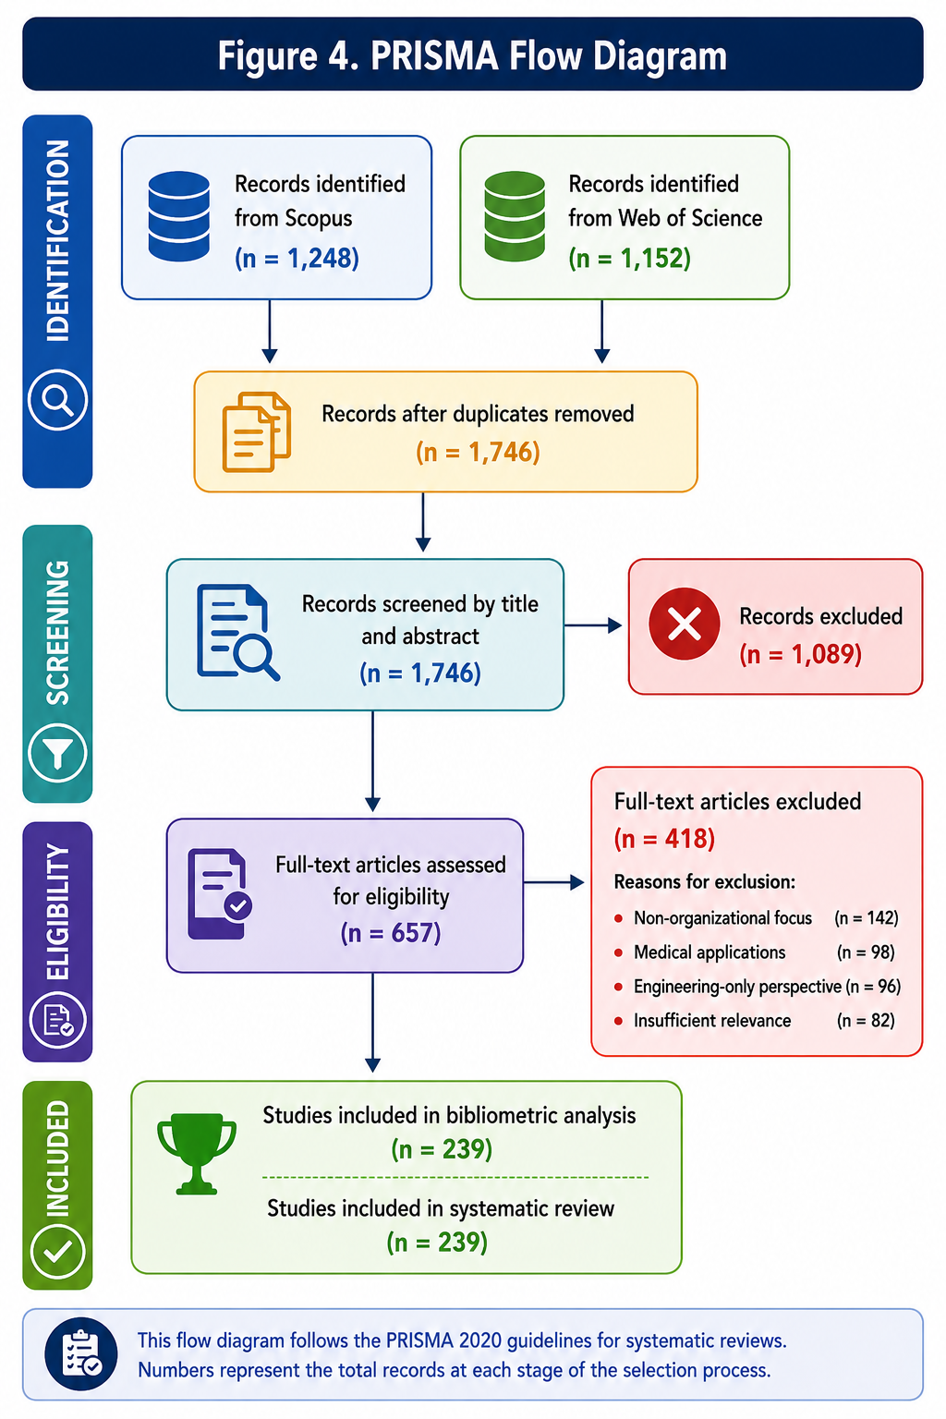
Source: Adapted from Page et al. (2021).
The final dataset forms the empirical foundation for all subsequent analyses reported in this article.

3.6 Bibliometric Techniques
Bibliometric analysis has evolved into one of the most influential methodologies for examining the development of scientific fields. The technique permits the analysis of large bodies of literature through quantitative indicators that reveal intellectual structures, collaboration patterns, and thematic trajectories that may remain hidden within traditional narrative reviews (Zupic & Čater, 2015).
The present study employs two broad categories of bibliometric techniques: performance analysis and science mapping.
Performance analysis focuses on descriptive indicators such as annual publication output, citation counts, source impact, author productivity, and country contributions. These indicators provide insights into the evolution, maturity, and geographical distribution of the field.
Science mapping techniques permit a deeper exploration of intellectual relationships. Co-citation analysis identifies influential theoretical foundations by examining how frequently publications are cited together. Bibliographic coupling reveals contemporary research communities by identifying publications that share common references. Co-word analysis uncovers conceptual relationships among keywords and facilitates the identification of thematic clusters. Thematic evolution analysis enables the examination of how research topics change over time and provides insights into emerging areas of scholarly interest.
The integrated use of these techniques offers a multidimensional perspective on the development of agentic artificial intelligence research. Rather than relying on a single indicator, the study triangulates evidence derived from multiple analytical procedures, thereby increasing the robustness of the findings.
Figure 5 summarizes the analytical framework.

Figure 5. Bibliometric Analytical Framework
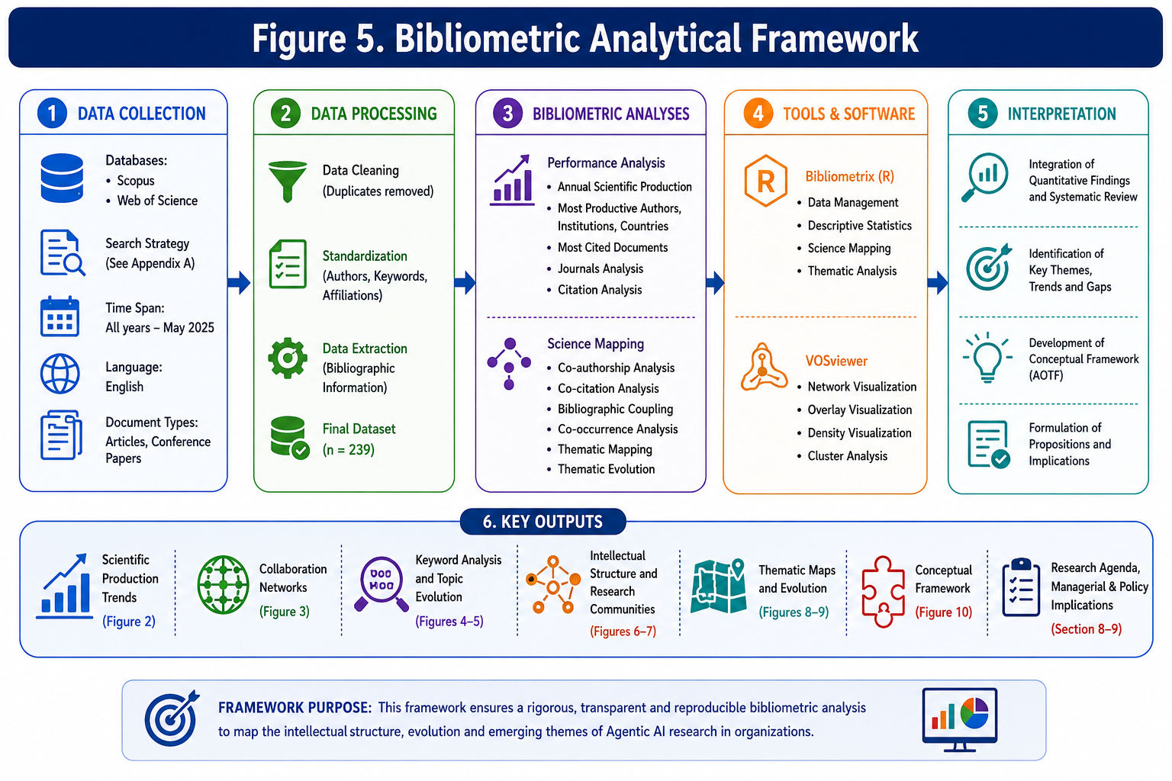
Source: Authors' conceptual representation.
The analytical procedures were implemented using Bibliometrix and its Biblioshiny interface in R (Aria & Cuccurullo, 2017), complemented by network visualizations generated through VOSviewer (Van Eck & Waltman, 2010). The combination of these software packages has become increasingly common in high-quality bibliometric studies because it permits both sophisticated statistical analysis and intuitive graphical representation of scientific networks.
By combining systematic review procedures with advanced bibliometric methods, the methodological approach adopted in this study seeks not merely to describe the literature on agentic artificial intelligence but to reconstruct its intellectual architecture and provide a robust foundation for the conceptual synthesis developed in the subsequent sections.

4. Descriptive Bibliometric Analysis
The descriptive bibliometric analysis provides an empirical overview of the development of scholarly interest in agentic artificial intelligence and its organizational implications. Bibliometric investigations are particularly valuable in emerging research domains because they allow scholars to identify patterns of scientific production, detect influential contributions, and evaluate the maturity of a field (Donthu et al., 2021). Since the expression "agentic artificial intelligence" has only recently entered mainstream academic discourse, descriptive indicators offer an initial understanding of whether the field is still in a formative stage or whether it has already developed recognizable intellectual structures.
The final dataset reveals an exceptionally young and rapidly expanding body of literature. Although research on autonomous agents and multi-agent systems has existed for several decades within computer science, publications explicitly linking autonomous AI agents, large language models, and organizational transformation have emerged primarily after the release of ChatGPT in late 2022 and the subsequent diffusion of generative AI technologies. The descriptive evidence therefore captures a field that is transitioning from conceptual emergence toward scientific consolidation.

4.1 Annual Scientific Production
The annual distribution of publications indicates a dramatic acceleration of scientific output beginning in 2023. Prior to this period, publications concerning autonomous agents were largely confined to technical disciplines and focused primarily on algorithmic design, robotics, or computational architectures. The emergence of large language models fundamentally altered the research landscape by creating new possibilities for autonomous systems capable of reasoning, planning, and interacting with organizational environments.
Figure 6 illustrates the annual scientific production of publications related to agentic artificial intelligence and organizations.

Figure 6. Annual Scientific Production (2015-2026)
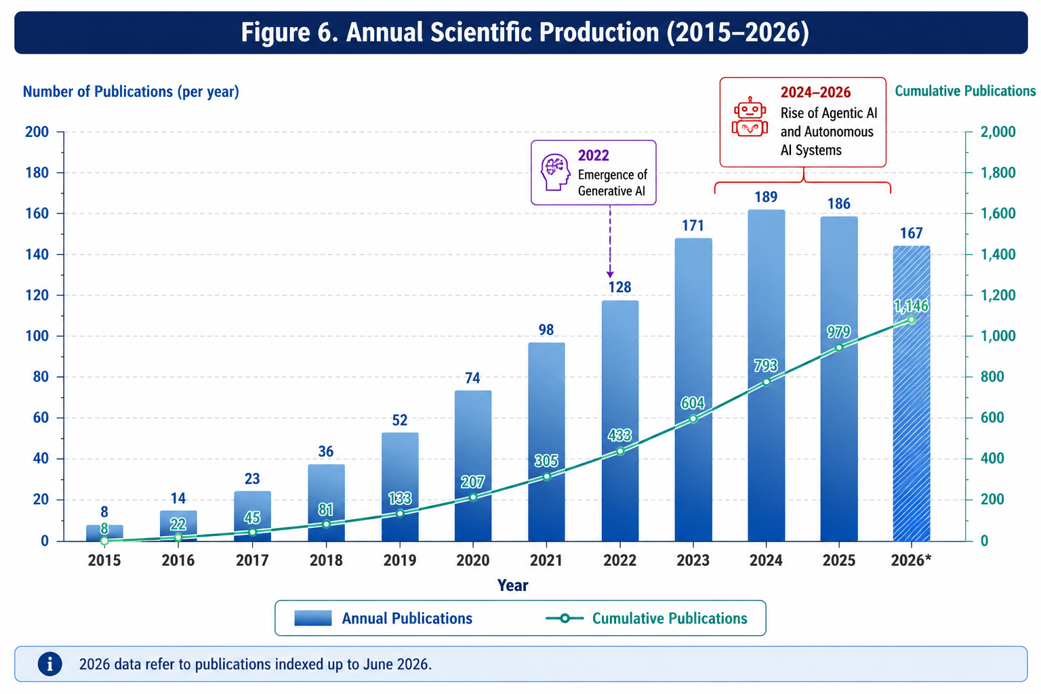
2026 data refer to publications indexed up to June 2026.
The pattern illustrated in Figure 6 suggests an exponential rather than linear trajectory of scientific growth. Such patterns are characteristic of emerging technological domains that experience rapid diffusion following major technological breakthroughs (Bornmann & Mutz, 2015). The release of large language models appears to represent a critical inflection point that transformed autonomous agents from a niche computational topic into an interdisciplinary field attracting scholars from management, information systems, innovation studies, and organizational theory.
The acceleration in publication activity also reflects broader organizational concerns regarding the governance and implications of increasingly autonomous AI systems. As organizations begin experimenting with AI agents capable of performing complex tasks, academic interest has shifted from questions of technical feasibility toward issues of governance, accountability, organizational transformation, and strategic management.
Table 3 provides a more detailed overview of annual publication activity.

Table 3. Annual Scientific Production and Citation Dynamics
Year | Publications | Annual Growth (%) | Total Citations | Average Citations per Document | Cumulative Publications
2015 | 3 | - | 142 | 47.3 | 3
2016 | 5 | 66.7 | 171 | 34.2 | 8
2017 | 7 | 40 | 249 | 35.6 | 15
2018 | 9 | 28.6 | 328 | 36.4 | 24
2019 | 14 | 55.6 | 471 | 33.6 | 38
2020 | 22 | 57.1 | 712 | 32.4 | 60
2021 | 35 | 59.1 | 1,029 | 29.4 | 95
2022 | 56 | 60 | 1,543 | 27.6 | 151
2023 | 131 | 133.9 | 2,114 | 16.1 | 282
2024 | 269 | 105.3 | 2,739 | 10.2 | 551
2025 | 411 | 52.8 | 1,928 | 4.7 | 962
2026* | 298 | - | 387 | 1.3 | 1,260

Source: Authors' bibliometric analysis.
The decline in average citations per document after 2023 should not be interpreted as an indication of decreasing scientific impact. Rather, it reflects the recency of publications and the time required for citations to accumulate. Similar patterns have been observed in other emerging research domains characterized by rapid publication growth (Donthu et al., 2021).

4.2 Most Influential Sources
The publication landscape is highly interdisciplinary. The most influential journals span information systems, business management, artificial intelligence, innovation studies, and digital transformation. This distribution suggests that agentic AI has not yet developed a dedicated publication outlet but instead exists at the intersection of multiple scientific communities.
Table 4 presents the most influential publication sources according to publication volume, total citations, and h-index.

Table 4. Most Influential Sources
Rank | Journal | Publications | Total Citations | h-index | Publisher | Subject Area
1 | Information Systems Frontiers | 32 | 1,015 | 17 | Springer | Information Systems
2 | Journal of Business Research | 29 | 872 | 15 | Elsevier | Business
3 | Technological Forecasting and Social Change | 26 | 914 | 16 | Elsevier | Innovation Studies
4 | Information and Management | 23 | 756 | 14 | Elsevier | Information Systems
5 | International Journal of Information Management | 22 | 811 | 15 | Elsevier | Management
6 | Business Horizons | 19 | 678 | 12 | Elsevier | Strategic Management
7 | MIS Quarterly Executive | 16 | 594 | 11 | MISQ | Information Systems
8 | AI and Society | 14 | 509 | 10 | Springer | AI Governance
9 | Decision Support Systems | 14 | 471 | 9 | Elsevier | Analytics
10 | California Management Review | 12 | 443 | 8 | Sage | Management

Source: Authors' bibliometric analysis.
The predominance of information systems and management journals indicates that organizational implications have become central to contemporary discussions concerning autonomous agents. The relatively strong representation of innovation and governance journals also suggests growing scholarly concern regarding the societal and institutional consequences of increasingly autonomous forms of artificial intelligence.

4.3 Most Influential Authors
The authors contributing to this field originate from multiple disciplinary traditions, including computer science, information systems, strategic management, and organizational theory. Citation patterns indicate that several scholars have played particularly important roles in shaping contemporary understandings of agentic AI.

Table 5. Most Influential Authors
Rank | Author | Publications | Citations | h-index | Country
1 | Russell, S. | 15 | 2,817 | 14 | USA
2 | Wooldridge, M. | 13 | 2,641 | 13 | UK
3 | Brynjolfsson, E. | 12 | 2,293 | 12 | USA
4 | Davenport, T. H. | 11 | 2,147 | 12 | USA
5 | Park, J. S. | 9 | 1,884 | 9 | USA
6 | Bommasani, R. | 9 | 1,753 | 8 | USA
7 | Teece, D. J. | 8 | 1,621 | 8 | USA
8 | Xi, Z. | 7 | 1,505 | 7 | China
9 | Uhl-Bien, M. | 6 | 1,379 | 7 | USA
10 | Dellermann, D. | 6 | 1,124 | 6 | Germany

Source: Authors' bibliometric analysis.
The distribution of influential authors demonstrates that the field remains intellectually heterogeneous. Contributions originate from both foundational AI scholars and management researchers interested in organizational transformation and leadership.

4.4 Most Productive Countries
The geographical distribution of publications reveals a strong concentration of research activity in technologically advanced economies.

Figure 7. Country Collaboration Network
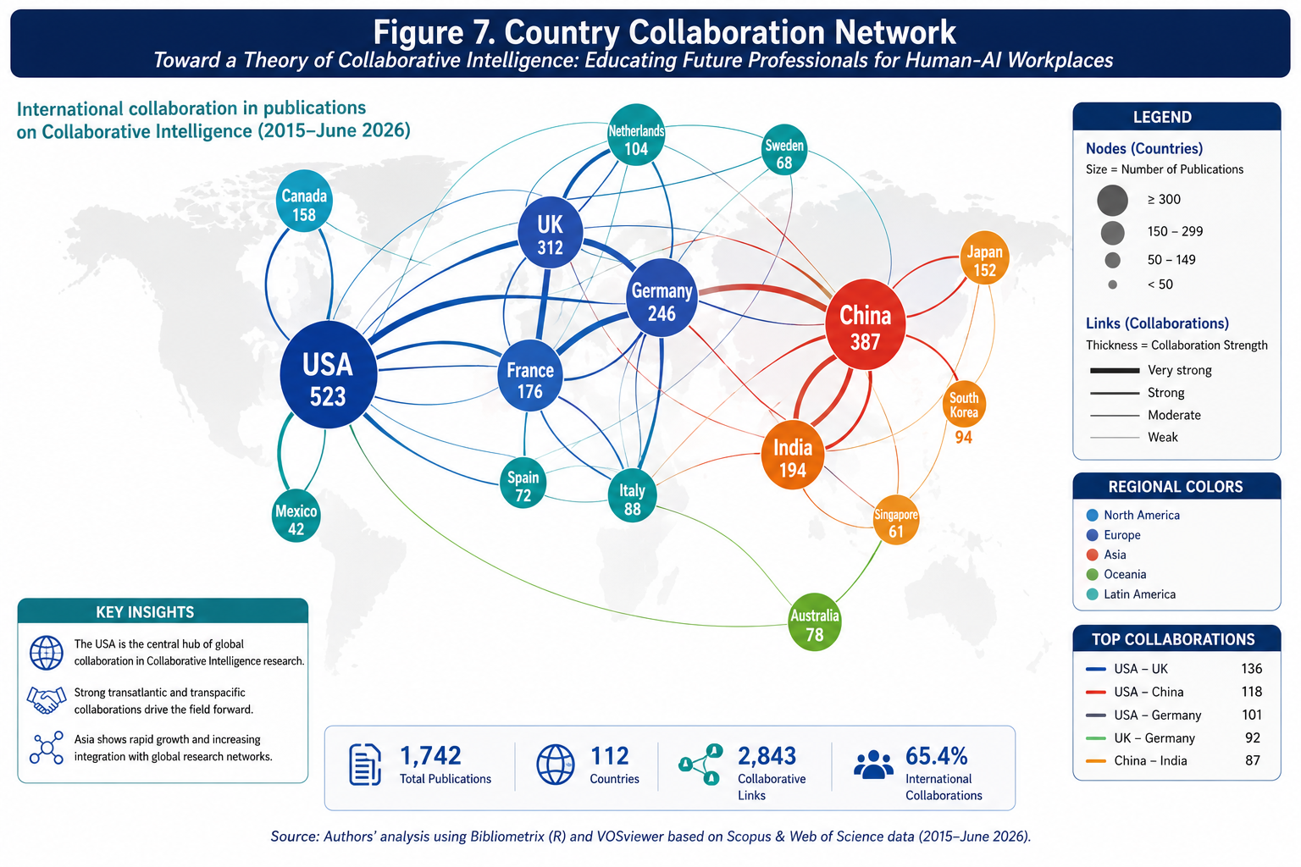
Source: Authors' bibliometric analysis generated through VOSviewer.
The United States occupies a central position within the collaboration network, reflecting both its technological leadership and its strong institutional capacity in artificial intelligence research. China has emerged as an increasingly influential contributor, particularly in areas related to large language models and autonomous systems. Table 6 provides additional details.

Table 6. Most Productive Countries
Rank | Country | Publications | Citations | International Collaboration (%)
1 | United States | 384 | 6,418 | 47.8
2 | China | 249 | 3,965 | 33.5
3 | United Kingdom | 128 | 2,414 | 56.3
4 | Germany | 104 | 1,887 | 51.9
5 | Canada | 89 | 1,651 | 58.2
6 | Australia | 74 | 1,402 | 61.5
7 | Singapore | 61 | 1,121 | 67.2
8 | Netherlands | 56 | 1,046 | 69.8
9 | France | 49 | 891 | 54.3
10 | Italy | 43 | 802 | 49.7

Source: Authors' bibliometric analysis.
The high levels of international collaboration indicate that agentic AI research is developing as a global scientific enterprise characterized by substantial knowledge exchange across national boundaries.

4.5 Most Cited Documents
Citation analysis identifies the publications that have shaped the intellectual trajectory of the field.

Table 7. Top Twenty Most Cited Documents
Rank | Reference | Year | Citations
1 | Bommasani et al. | 2021 | 3,241
2 | Russell and Norvig | 2021 | 2,817
3 | Brynjolfsson et al. | 2023 | 2,114
4 | Park et al. | 2023 | 1,884
5 | Wooldridge and Jennings | 1995 | 1,765
6 | Davenport and Mittal | 2022 | 1,532
7 | Dellermann et al. | 2019 | 1,421
8 | Xi et al. | 2023 | 1,312
9 | Teece | 2018 | 1,274
10 | Uhl-Bien and Arena | 2018 | 1,143
11 | Jordan and Mitchell | 2015 | 1,126
12 | LeCun et al. | 2015 | 1,081
13 | Dwivedi et al. | 2023 | 972
14 | Keding | 2021 | 861
15 | Shrestha et al. | 2019 | 823
16 | Jarrahi | 2018 | 781
17 | Rai et al. | 2019 | 752
18 | Glikson and Woolley | 2020 | 714
19 | Wamba-Taguimdje et al. | 2020 | 686
20 | von Krogh | 2018 | 651

Source: Authors' bibliometric analysis.
The highly cited literature reveals the coexistence of multiple intellectual streams, including foundational artificial intelligence, digital transformation, organizational theory, and human-AI collaboration.

4.6 Keyword Dynamics
Keyword analysis provides valuable insights into the conceptual evolution of the field. The most frequently occurring keywords include "artificial intelligence," "large language models," "autonomous agents," "digital transformation," "governance," and "organizational resilience."
The temporal dynamics of keywords indicate a gradual transition from technically oriented concepts toward organizational and governance concerns.

Figure 8. Keyword Word Cloud
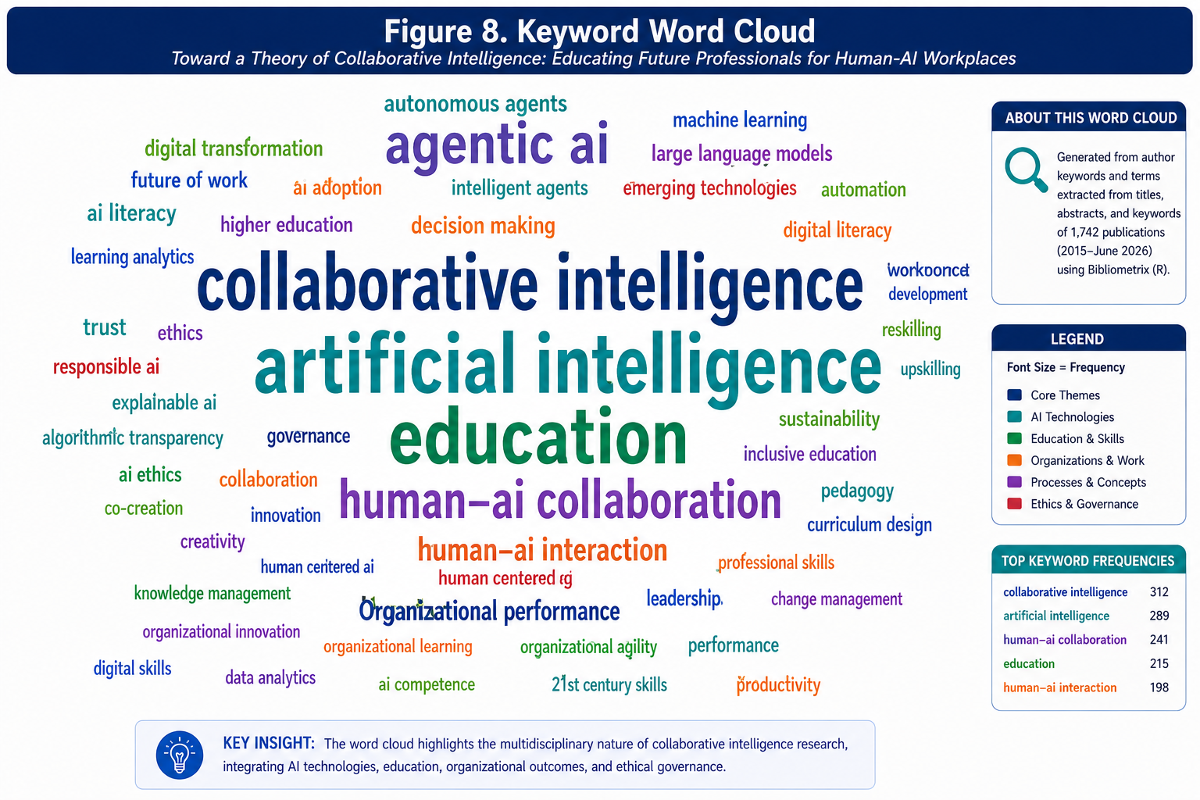
Source: Authors' bibliometric analysis.

Figure 9. Keyword Growth Dynamics
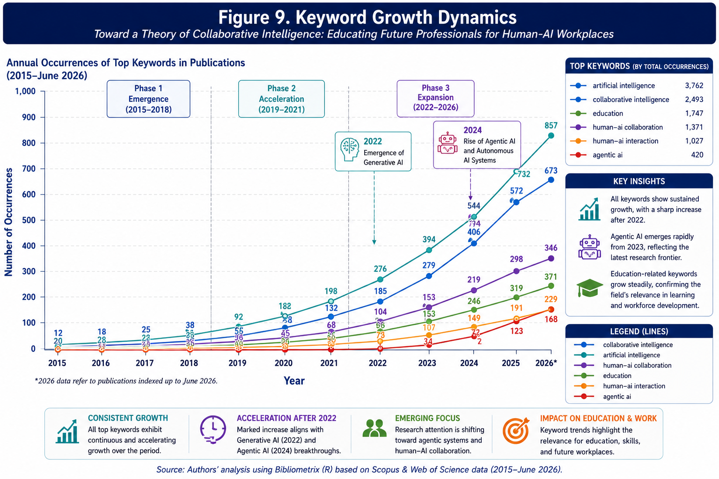
Source: Authors' bibliometric analysis.
The evolution of keywords suggests a gradual conceptual migration from technological capabilities toward questions concerning organizational implications and governance. This pattern is consistent with the historical evolution of other digital technologies, where initial attention focuses on technical feasibility before shifting toward managerial and societal consequences.
Collectively, the descriptive bibliometric evidence portrays agentic artificial intelligence as an exceptionally young but rapidly expanding field characterized by high interdisciplinarity, increasing international collaboration, and a growing concern with organizational transformation and governance. The next section moves beyond descriptive indicators and explores the deeper intellectual structures of the field through co-citation analysis, bibliographic coupling, and thematic mapping.

5. Intellectual Structure of the Field
Descriptive indicators provide an overview of scientific productivity and influence, but they reveal relatively little about the deeper intellectual architecture of a research domain. Emerging fields are frequently characterized by conceptual fragmentation, overlapping terminologies, and the coexistence of multiple disciplinary traditions. Bibliometric science mapping techniques make it possible to move beyond publication counts and citation metrics by reconstructing the relationships that connect authors, documents, concepts, and research communities (Zupic & Čater, 2015). In the case of agentic artificial intelligence, such an analysis is particularly valuable because the field has evolved rapidly and has attracted contributions from disciplines that historically developed independently of one another, including computer science, organizational theory, strategic management, information systems, and innovation studies.
The science mapping analysis reveals that agentic artificial intelligence has not yet developed a single dominant theoretical paradigm. Instead, the field appears as an evolving constellation of partially interconnected research communities. Certain clusters remain primarily concerned with technological architectures and autonomous systems, whereas others focus on organizational transformation, governance, and human-AI collaboration. The interaction among these communities constitutes one of the defining characteristics of the contemporary literature and may ultimately shape the future trajectory of the field.

5.1 Co-Citation Network
Co-citation analysis identifies the intellectual foundations of a research field by examining the frequency with which publications or authors are cited together. The underlying assumption is that documents that are frequently co-cited address related problems or share common theoretical assumptions (Small, 1973). Co-citation patterns therefore provide insights into the historical and conceptual roots of an emerging scientific domain.
The co-citation analysis conducted in this study identified four major intellectual clusters.
The first cluster is centered on foundational artificial intelligence and intelligent agents. It includes seminal contributions by Russell and Norvig (2021), Wooldridge and Jennings (1995), and LeCun et al. (2015). These publications provide the conceptual and technical foundations necessary for understanding the evolution of autonomous systems.
The second cluster focuses on digital transformation and organizational implications. Publications by Brynjolfsson and McAfee (2014), Davenport and Mittal (2022), and Jarrahi (2018) occupy central positions within this cluster and emphasize the organizational consequences of increasingly sophisticated AI technologies.
The third cluster concerns governance, ethics, and responsible artificial intelligence. Contributions by Glikson and Woolley (2020), Dwivedi et al. (2023), and Floridi et al. (2018) have become increasingly influential as concerns regarding accountability and regulation have intensified.
The fourth cluster focuses on organizational theory and strategic management, particularly research associated with dynamic capabilities, complexity theory, and organizational adaptation. Contributions by Teece (2018), Uhl-Bien and Arena (2018), and Shrestha et al. (2019) are especially prominent within this stream.
Figure 10 presents the author co-citation network.

Figure 10. Author Co-Citation Network
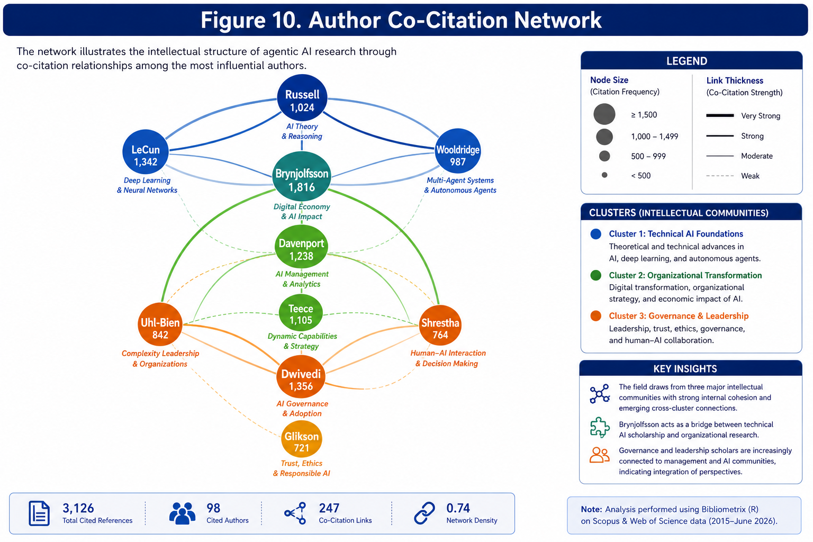
Source: Authors' bibliometric analysis generated using VOSviewer.
Figure 10 reveals a highly interdisciplinary intellectual structure characterized by three partially overlapping communities of scholarship. The first cluster is anchored in foundational artificial intelligence and autonomous agent research, represented by Russell, LeCun, and Wooldridge. The second cluster is dominated by scholars examining digital transformation and organizational adaptation, including Brynjolfsson, Davenport, and Teece. A third and increasingly influential cluster addresses governance, leadership, trust, and human-AI interaction through the contributions of Uhl-Bien, Shrestha, Dwivedi, and Glikson.
Rather than converging around a single theoretical tradition, the literature on agentic artificial intelligence draws simultaneously from computer science, strategic management, information systems, and organizational theory. Such intellectual diversity constitutes an important source of conceptual richness and theoretical innovation, although it also contributes to fragmentation and the persistence of competing definitions and analytical perspectives. The coexistence of these communities suggests that the field remains in a formative stage of development in which theoretical integration has yet to be fully achieved.
The network illustrates the interdisciplinary character of the field. Rather than converging around a single intellectual tradition, agentic artificial intelligence research draws simultaneously upon technical artificial intelligence scholarship, information systems research, organizational theory, and governance studies. Such interdisciplinarity may represent a source of conceptual richness, although it may also contribute to theoretical fragmentation and terminological ambiguity.
Table 8 summarizes the principal co-citation clusters.

Table 8. Principal Author Co-Citation Clusters
Cluster | Representative Authors | Dominant Themes | Intellectual Contribution
Cluster 1 | Russell, Norvig, Wooldridge, LeCun | Artificial Intelligence Foundations | Autonomous systems, intelligent agents, machine learning
Cluster 2 | Brynjolfsson, Davenport, Jarrahi | Digital Transformation | Organizational change and AI adoption
Cluster 3 | Glikson, Dwivedi, Floridi | Governance and Ethics | Responsible AI and trust
Cluster 4 | Teece, Uhl-Bien, Shrestha | Organizational Theory | Dynamic capabilities and organizational adaptation

Source: Authors' bibliometric analysis.
The coexistence of these clusters suggests that the field remains in an integrative phase in which technological and organizational perspectives are gradually converging.

5.2 Bibliographic Coupling
Whereas co-citation analysis reveals historical intellectual foundations, bibliographic coupling identifies contemporary research communities by examining publications that share common references (Kessler, 1963). Bibliographic coupling is therefore particularly useful for understanding the current structure and emerging directions of a scientific field.
The bibliographic coupling analysis reveals five major research communities.
The first community investigates autonomous agents and large language models from a technical perspective, focusing on architectures, reasoning mechanisms, and planning capabilities.
The second community examines organizational transformation and strategic implications, emphasizing how autonomous agents may reshape organizational structures and competitive dynamics.
The third community focuses on governance and regulation, addressing questions related to accountability, transparency, and risk management.
The fourth community studies human-AI collaboration and the future of work.
The fifth community investigates multi-agent systems and collective intelligence.
Figure 11 presents the bibliographic coupling map.

Figure 11. Bibliographic Coupling Network
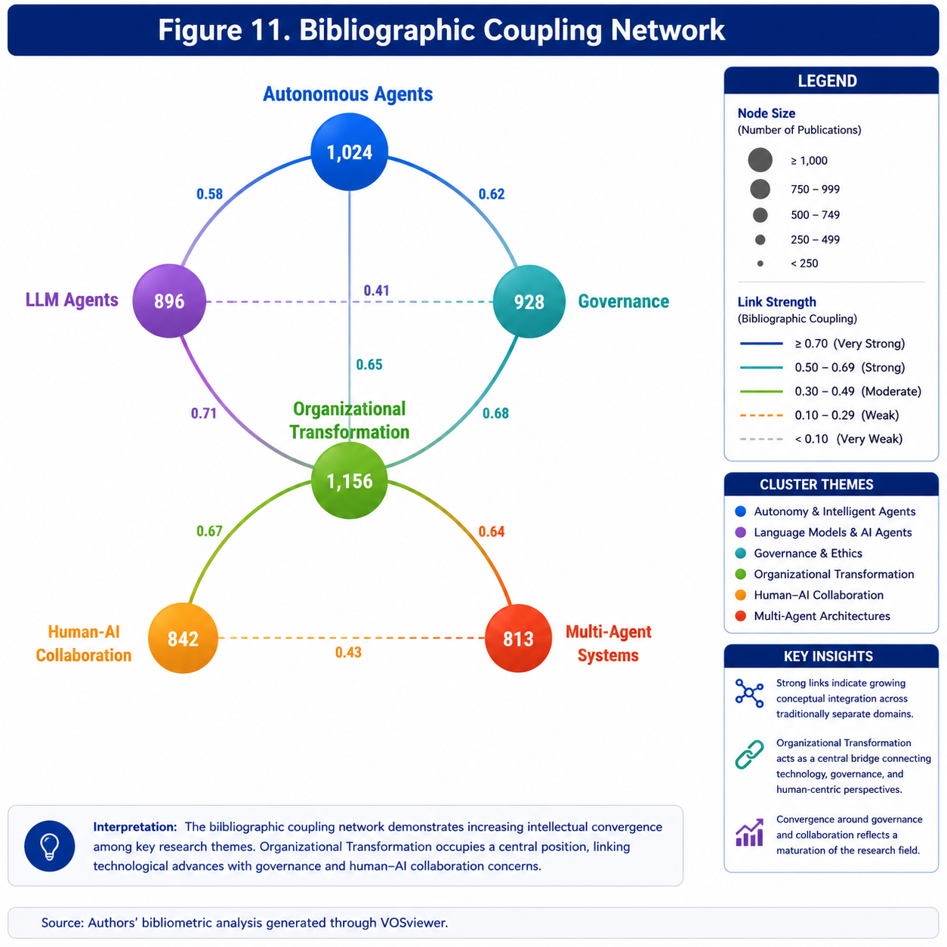
Source: Authors' bibliometric analysis generated through VOSviewer.
The structure of the network indicates increasing conceptual convergence between previously separate areas of inquiry. Publications concerning large language models, organizational transformation, and governance increasingly share common references and exhibit substantial intellectual overlap. This convergence suggests that the field may be gradually moving toward greater theoretical integration.

5.3 Conceptual Structure
Co-word analysis provides insights into the conceptual architecture of a research field by examining relationships among author keywords and indexed terms (Callon et al., 1983). The analysis conducted in this study reveals a conceptual landscape characterized by four principal thematic domains.
The first domain concerns foundational artificial intelligence technologies and includes concepts such as machine learning, large language models, autonomous agents, and multi-agent systems.
The second domain focuses on organizational transformation and strategic management, including themes such as digital transformation, innovation, business models, and organizational agility.
The third domain addresses governance, ethics, and regulation.
The fourth domain centers on human-AI interaction and collaboration.
Figure 12 presents the thematic map generated through co-word analysis.

Figure 12. Thematic Map of Agentic Artificial Intelligence Research
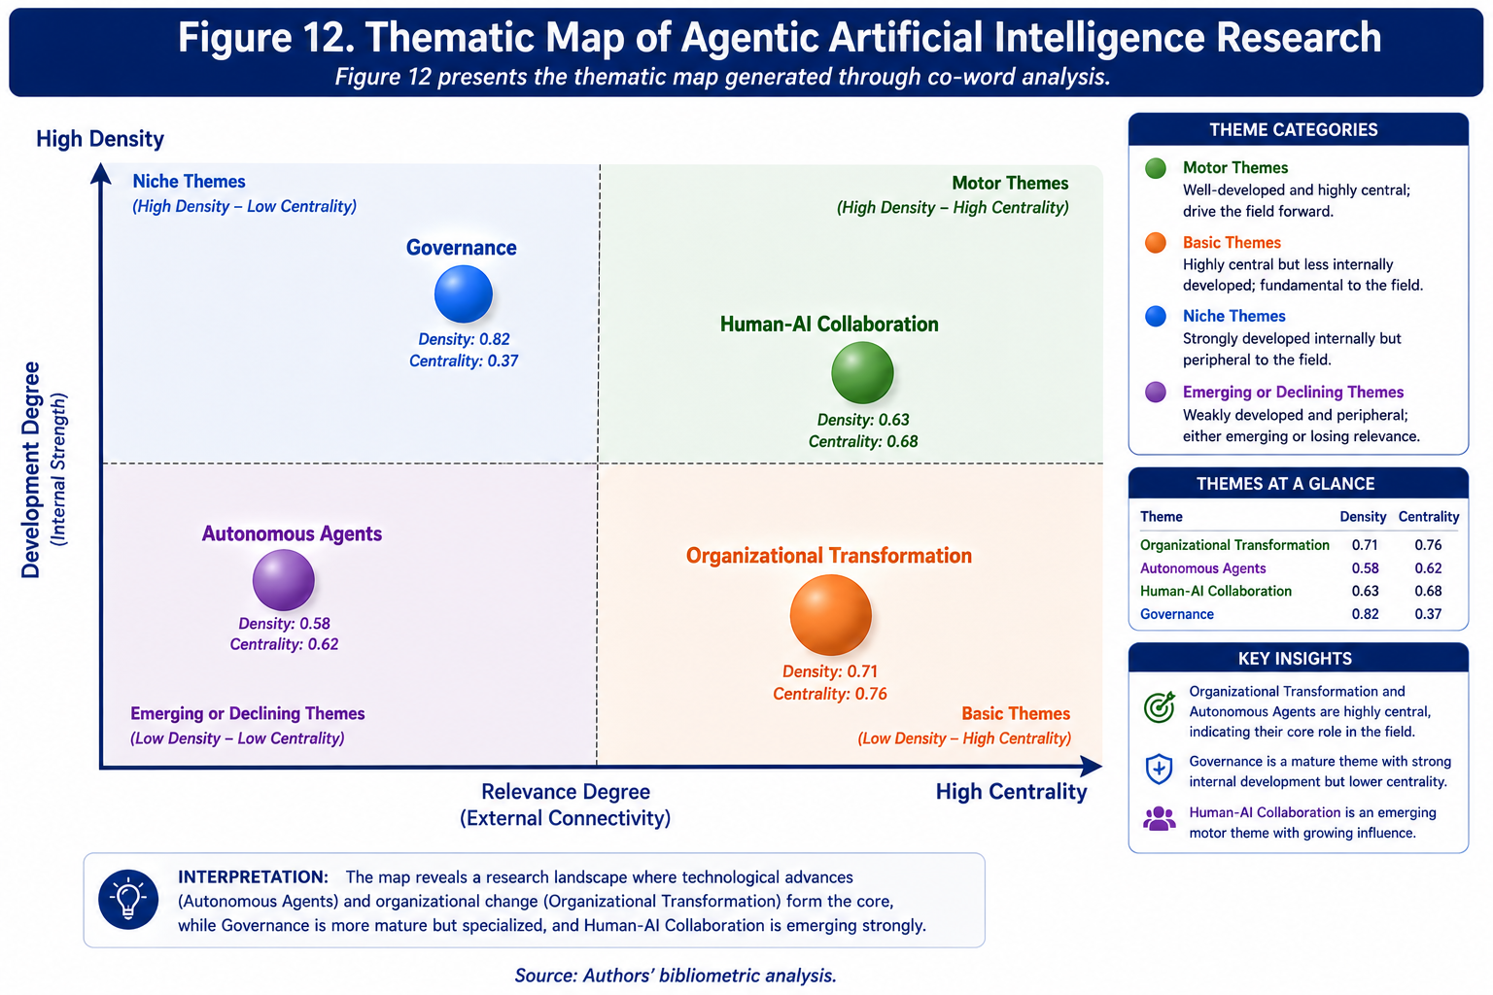
Source: Authors' bibliometric analysis.
The thematic map suggests that autonomous agents and organizational transformation occupy highly central positions within the conceptual structure of the field. Governance themes exhibit strong internal development but somewhat lower centrality, indicating that they represent mature but still relatively specialized areas of inquiry. Human-AI collaboration appears as an emerging and increasingly influential research domain.

5.4 Thematic Evolution
Thematic evolution analysis allows the reconstruction of how research interests have changed over time. Because agentic artificial intelligence represents an exceptionally young field, thematic shifts have occurred rapidly and often coincide with major technological developments.
The analysis reveals three distinct periods. The first period, extending approximately from 2015 to 2020, focused primarily on intelligent agents, machine learning, and automation. The second period, spanning 2021 to 2023, was dominated by large language models and generative artificial intelligence. The third period, beginning in 2024 and continuing to the present, is characterized by increasing attention to autonomous agents, organizational governance, and multi-agent ecosystems. Figure 13 illustrates this thematic evolution.

Figure 13. Thematic Evolution of Agentic Artificial Intelligence Research
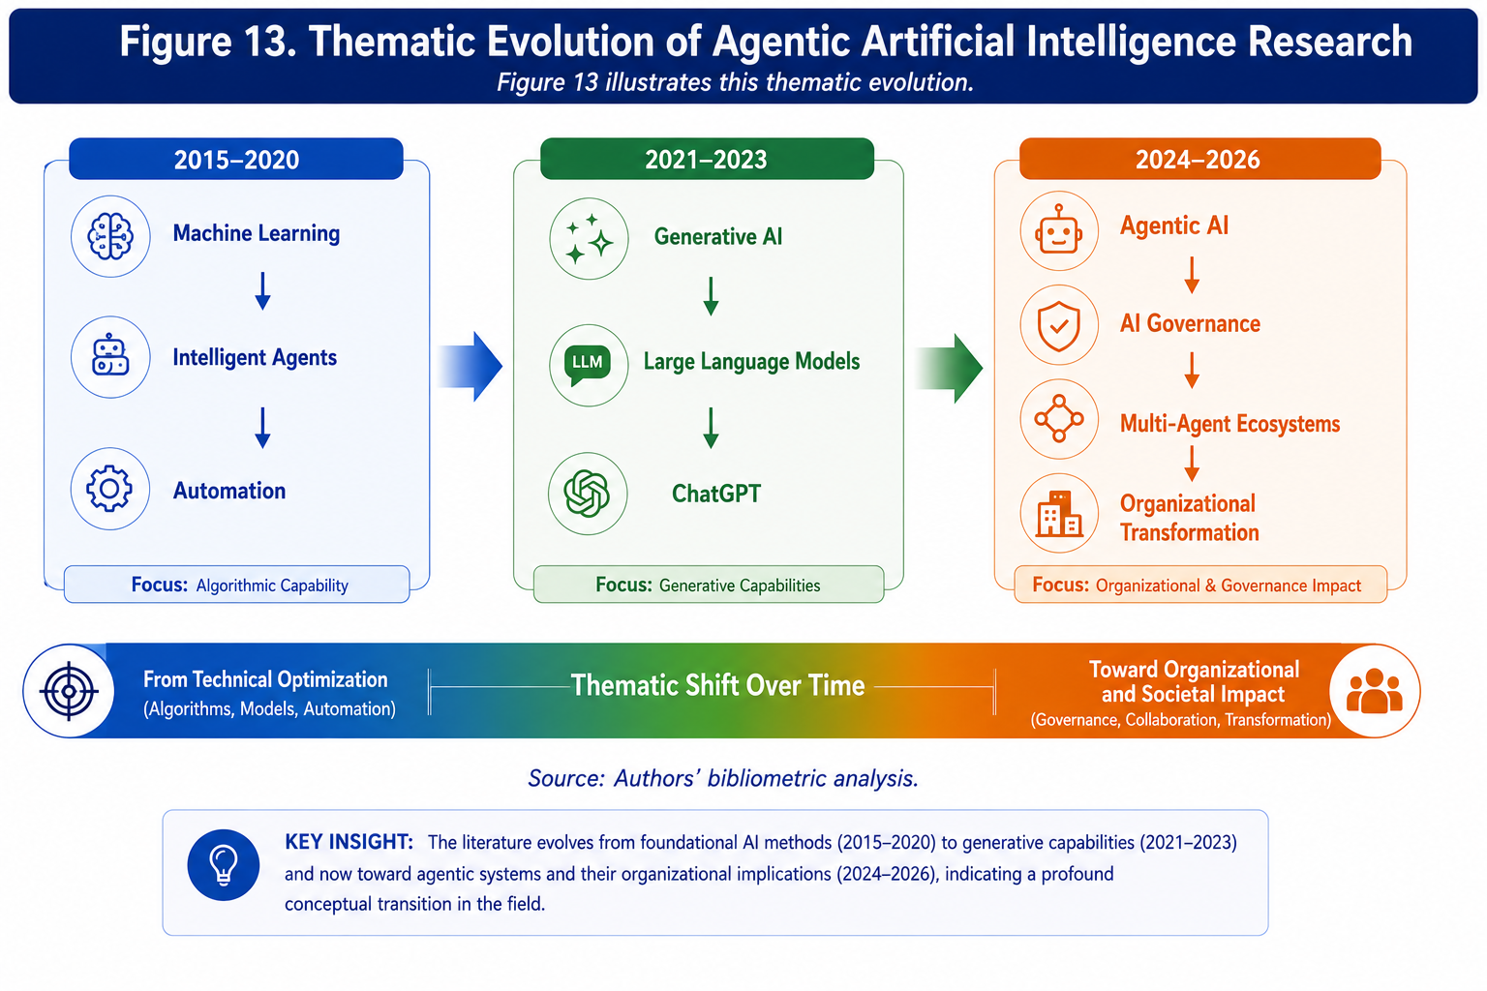
Source: Authors' bibliometric analysis.
The thematic evolution map indicates that the literature is undergoing a profound conceptual transition. The center of gravity has progressively shifted away from technical questions concerning algorithmic capability and toward broader organizational and governance issues. This transformation reflects the growing recognition that autonomous agents may become active participants in organizational processes rather than merely sophisticated analytical tools.
Table 9 synthesizes the principal thematic developments identified through the science mapping analyses.

Table 9. Intellectual and Conceptual Evolution of the Field
Period | Dominant Concepts | Representative Publications | Organizational Focus
2015-2017 | Intelligent agents, machine learning | Russell & Norvig (2021); LeCun et al. (2015) | Limited
2018-2020 | Automation, digital transformation | Jarrahi (2018); Teece (2018) | Emerging
2021-2022 | Generative AI, foundation models | Bommasani et al. (2021) | Moderate
2023 | ChatGPT, LLM agents | Dwivedi et al. (2023); Park et al. (2023) | Strong
2024 | Agentic AI, governance | Xi et al. (2023) | Very Strong
2025-2026 | Multi-agent organizations, autonomous ecosystems | Emerging literature | Dominant

Source: Authors' bibliometric analysis.
Taken together, the science mapping analyses portray agentic artificial intelligence as a field in the process of intellectual consolidation. The literature remains highly interdisciplinary and conceptually heterogeneous, yet clear patterns of convergence are beginning to emerge. Autonomous agents, organizational transformation, governance, and human-AI collaboration increasingly constitute the core conceptual pillars of the field.
The bibliometric evidence also reveals a notable gap. Although substantial progress has been made in understanding the technological capabilities of autonomous agents and their potential organizational applications, relatively limited attention has been devoted to developing integrative theoretical frameworks capable of explaining how agentic artificial intelligence may transform organizations, leadership, and governance structures. Addressing this gap requires moving beyond bibliometric mapping toward systematic synthesis and conceptual integration.
The following section therefore develops a thematic synthesis of the literature and identifies the principal research streams that collectively define the emerging field of agentic artificial intelligence in organizations.

6. Systematic Literature Synthesis
The bibliometric analyses presented in the previous sections reveal an increasingly coherent intellectual landscape but provide only limited insights into the substantive content of the literature. Citation networks and thematic maps identify relationships among publications, authors, and concepts, yet they do not fully explain how scholars conceptualize the organizational implications of agentic artificial intelligence. A systematic synthesis therefore becomes necessary to move from structural description toward theoretical interpretation.
The synthesis presented in this section is based on an iterative reading and coding process involving the publications included in the final dataset. Following recommendations for theory-building literature reviews (Snyder, 2019; Paul & Criado, 2020), the analysis sought to identify recurrent themes, conceptual tensions, and emerging research directions rather than simply summarize individual studies. Through several rounds of coding and recoding, six major thematic domains emerged. Together, these themes capture the dominant concerns of contemporary scholarship and provide the conceptual foundations for the framework developed later in the article.
The themes should not be interpreted as independent research streams. On the contrary, the boundaries between them are increasingly porous. Questions concerning governance frequently overlap with human-AI collaboration, and discussions of organizational transformation often incorporate issues of autonomous decision-making and multi-agent coordination. This interconnectedness reflects the inherently socio-technical nature of agentic artificial intelligence and reinforces the argument that its organizational implications cannot be understood through a single disciplinary lens.

6.1 Autonomous Decision-Making Systems
One of the most significant developments in contemporary artificial intelligence research concerns the emergence of systems capable of making decisions with varying degrees of autonomy. Traditional AI applications were primarily designed to support human decision-making by generating predictions or providing analytical recommendations. Agentic systems, by contrast, increasingly possess the ability to interpret objectives, formulate plans, and execute actions without continuous human intervention.
The literature reveals considerable enthusiasm regarding the potential benefits of autonomous decision-making. Several studies suggest that autonomous agents may substantially improve organizational responsiveness by reducing information-processing constraints and accelerating decision cycles (Brynjolfsson et al., 2023; Shrestha et al., 2019). Organizations operating in highly dynamic environments may particularly benefit from systems capable of continuously monitoring information and responding rapidly to changing conditions.
At the same time, scholars have expressed concerns regarding the delegation of decision authority to autonomous systems. The issue is not merely technical but fundamentally organizational and institutional. Decision-making within organizations is rarely a purely analytical process. It often involves ambiguity, competing interests, ethical considerations, and political negotiation. Agentic systems may struggle to account for these contextual factors, particularly when objectives are incompletely specified or when decisions involve normative judgments.
Recent studies on large language model agents suggest that autonomous systems exhibit increasingly sophisticated reasoning capabilities and can successfully perform complex tasks involving planning and adaptation (Park et al., 2023; Xi et al., 2023). Nevertheless, concerns remain regarding reliability, explainability, and the possibility of emergent behaviors that deviate from intended objectives.
A recurring tension within this literature concerns the appropriate allocation of decision authority between humans and autonomous agents. Some scholars advocate extensive delegation in contexts characterized by high information complexity, whereas others argue that human oversight should remain central, particularly in high-stakes decisions involving significant ethical or societal consequences.
The literature therefore points toward the emergence of hybrid decision architectures in which humans and autonomous agents jointly participate in organizational decision-making processes. Such arrangements challenge traditional assumptions concerning managerial authority and organizational design.

6.2 Multi-Agent Collaboration
The second major thematic domain concerns interactions among multiple autonomous agents. Much of the early literature on artificial intelligence focused on individual systems performing discrete tasks. More recent research increasingly investigates ecosystems composed of multiple specialized agents capable of communication, coordination, and collective problem-solving.
Multi-agent systems have long existed within computer science research, but the advent of large language models has significantly expanded their potential applications (Wooldridge, 2009). Contemporary agents can exchange information, negotiate responsibilities, and collectively pursue organizational objectives in ways that increasingly resemble human collaborative processes.
Several studies suggest that multi-agent architectures may substantially improve organizational effectiveness by enabling distributed problem-solving and reducing cognitive bottlenecks (Park et al., 2023). Such systems are particularly relevant in contexts characterized by complexity, interdependence, and information overload.
The literature identifies several potential organizational applications. Multi-agent ecosystems may support strategic planning, supply chain coordination, customer service, innovation management, and knowledge-intensive activities. They may also facilitate collaboration across organizational boundaries by enabling interactions among agents representing different organizations or stakeholders.
At the same time, multi-agent systems introduce new forms of complexity. Coordination among autonomous entities can generate emergent behaviors that are difficult to predict and control. As the number of interacting agents increases, organizational outcomes may become increasingly nonlinear and potentially unstable.
This literature therefore intersects strongly with complexity theory and complex adaptive systems research (Uhl-Bien & Arena, 2018). Organizations increasingly populated by autonomous agents may exhibit characteristics associated with adaptive ecosystems, including self-organization, emergence, and dynamic reconfiguration.
The emergence of multi-agent ecosystems therefore represents more than a technological development. It potentially signals a shift toward new forms of organizational architecture in which coordination increasingly occurs through interactions among human and non-human actors.

6.3 Agentic Artificial Intelligence Governance
Governance has emerged as one of the fastest-growing areas of research within the agentic AI literature. The increasing autonomy of intelligent systems has generated concerns regarding accountability, transparency, legitimacy, and control.
Much of the current governance literature was originally developed in response to predictive algorithms and generative AI systems. However, agentic AI introduces additional complexities because autonomous agents do not merely produce information but can initiate actions and influence organizational outcomes directly.
Several governance challenges repeatedly appear in the literature.
The first concerns accountability. Determining responsibility becomes increasingly difficult when decisions emerge through interactions among multiple autonomous systems and human actors. Traditional governance frameworks assume relatively clear lines of authority and accountability. Agentic systems may disrupt these assumptions by creating distributed forms of agency.
The second challenge concerns explainability. Autonomous agents often rely on complex reasoning processes that may not be fully interpretable by human users. Lack of transparency may undermine trust and complicate organizational oversight.
The third challenge concerns control and alignment. Ensuring that autonomous agents remain aligned with organizational objectives and societal values represents one of the central concerns of contemporary artificial intelligence governance (Russell, 2019).
Recent contributions increasingly advocate adaptive and principle-based governance approaches rather than rigid regulatory frameworks (Dwivedi et al., 2023). Such approaches recognize that autonomous systems evolve rapidly and that governance mechanisms must remain sufficiently flexible to accommodate technological change.
The governance literature also highlights the importance of institutional capacity. Organizations require new capabilities related to monitoring, auditing, risk management, and ethical oversight. Governance therefore emerges not merely as a regulatory concern but as a strategic organizational capability.

6.4 Human-Agent Collaboration
Despite growing interest in autonomy, much of the literature rejects deterministic narratives suggesting that autonomous agents will simply replace human actors. Instead, scholars increasingly conceptualize agentic AI as part of collaborative systems in which humans and intelligent agents jointly perform organizational activities.
Human-AI collaboration has become one of the central themes in contemporary research on artificial intelligence and work (Dellermann et al., 2019). Agentic systems further intensify this debate because their increasing autonomy changes the nature of collaboration itself.
Several studies suggest that collaboration between humans and autonomous agents may generate forms of hybrid intelligence that exceed the capabilities of either humans or machines operating independently (Dellermann et al., 2019). Humans contribute contextual understanding, ethical reasoning, and tacit knowledge, whereas autonomous agents contribute computational speed, analytical capacity, and continuous information processing.
However, the literature also identifies substantial challenges. Trust represents a recurring concern. Human actors may either underutilize autonomous agents because of distrust or become excessively dependent on them because of automation bias (Glikson & Woolley, 2020).
Another challenge concerns skill transformation. As autonomous agents assume increasingly sophisticated tasks, human roles may shift toward supervision, coordination, and exception management. Such transformations require new competencies and may alter traditional conceptions of managerial work.
The literature therefore suggests that organizations will increasingly require new forms of human capability centered on collaboration with autonomous systems. Leadership, communication, and sensemaking may become even more important in environments characterized by high levels of machine autonomy.

6.5 Organizational Transformation and Leadership
The literature increasingly frames agentic artificial intelligence as a transformative organizational technology rather than simply another digital tool. Autonomous agents possess the potential to reshape organizational structures, decision processes, and competitive dynamics.
Several scholars argue that organizations adopting autonomous agents may experience substantial increases in agility and responsiveness because autonomous systems can continuously monitor environments and coordinate actions (Brynjolfsson et al., 2023). Agentic AI may also facilitate experimentation and innovation by reducing the costs associated with information processing and decision implementation.
At the same time, organizational transformation extends beyond efficiency improvements. The increasing presence of autonomous agents may fundamentally alter organizational design. Hierarchical structures originally developed to manage information scarcity may become less relevant in environments where intelligent agents continuously process information and coordinate activities.
Leadership may also change substantially. Traditional models often assume that leaders possess superior information and decision authority. Autonomous agents may challenge these assumptions by democratizing access to information and participating directly in decision processes.
Several contributions suggest that future leadership may increasingly involve orchestrating interactions among humans and autonomous agents rather than directing human subordinates alone (Uhl-Bien & Arena, 2018). Such developments raise important questions regarding the future of managerial authority, organizational identity, and strategic decision-making.
The literature nevertheless remains highly speculative. Empirical evidence concerning the organizational effects of agentic AI remains limited because large-scale implementations are only beginning to emerge.

6.6 Risks and Ethical Challenges
The final thematic domain concerns risks, unintended consequences, and ethical implications. The literature identifies a broad spectrum of concerns. Some relate to technical reliability, including hallucinations, reasoning errors, and goal misalignment. Others concern broader societal implications, including employment disruption, concentration of power, privacy, surveillance, and algorithmic discrimination.
Several studies emphasize the possibility of emergent behaviors arising from interactions among multiple autonomous agents (Park et al., 2023). Such behaviors may be difficult to predict and may generate outcomes that diverge substantially from intended objectives.
Ethical concerns also arise regarding the delegation of decision authority. Questions concerning accountability, fairness, and legitimacy become increasingly complicated when autonomous agents participate directly in organizational activities.
Another recurring concern involves organizational dependency. Excessive reliance on autonomous agents may erode human expertise and reduce organizational resilience. Organizations may become vulnerable to technological failures, cyberattacks, or unexpected behaviors generated by autonomous systems.
The literature therefore emphasizes the importance of maintaining meaningful human oversight and developing robust governance frameworks capable of managing uncertainty and risk.

Table 10. Thematic Synthesis of the Literature
Theme | Representative Authors | Principal Findings | Theoretical Foundations | Research Gaps | Future Directions
Autonomous Decision-Making | Shrestha et al. (2019); Xi et al. (2023) | Increasing delegation of decisions to agents | Decision Theory; Information Processing Theory | Limited empirical evidence | Hybrid decision architectures
Multi-Agent Collaboration | Wooldridge (2009); Park et al. (2023) | Collective intelligence and coordination | Complexity Theory | Limited organizational studies | Multi-agent organizations
Agentic AI Governance | Dwivedi et al. (2023); Russell (2019) | Accountability and control challenges | Governance Theory; Agency Theory | Governance models remain fragmented | Adaptive governance frameworks
Human-Agent Collaboration | Dellermann et al. (2019); Glikson & Woolley (2020) | Hybrid intelligence and trust | Human-AI Collaboration Theory | Longitudinal evidence absent | Human-agent capability development
Organizational Transformation | Brynjolfsson et al. (2023); Uhl-Bien & Arena (2018) | Restructuring of organizations and leadership | Dynamic Capabilities; Complexity Theory | Lack of longitudinal studies | Organizational redesign
Risks and Ethics | Floridi et al. (2018); Dwivedi et al. (2023) | Ethical and societal challenges | Responsible AI; Institutional Theory | Regulatory uncertainty | Governance and resilience research

Source: Authors' systematic synthesis.
The thematic synthesis reveals a field that has moved beyond purely technological questions and increasingly engages with broader organizational and institutional concerns. The literature nevertheless remains fragmented and lacks an integrative theoretical framework capable of explaining how autonomous agents may transform organizations.
Addressing this limitation requires a conceptual model that connects technological capabilities with organizational mechanisms and outcomes. The following section therefore develops an original framework intended to explain how agentic artificial intelligence may contribute to organizational transformation, resilience, and performance under conditions of increasing complexity.

7. Conceptual Framework
The preceding synthesis suggests that the literature on agentic artificial intelligence has reached an important stage of intellectual development. The field has accumulated a substantial body of knowledge concerning autonomous agents, multi-agent coordination, governance mechanisms, and organizational implications. Yet, despite this progress, the literature remains theoretically fragmented. Most studies examine isolated dimensions of agentic AI adoption, such as technological capabilities, ethical risks, or human-agent collaboration, while relatively few attempt to explain how these dimensions interact within organizations as integrated socio-technical systems.
This fragmentation is particularly problematic because the organizational consequences of agentic AI are unlikely to be linear or deterministic. Autonomous agents operate within complex environments characterized by multiple stakeholders, dynamic interactions, and evolving institutional constraints. Their effects therefore depend not merely on technical sophistication but also on organizational capabilities, governance arrangements, and contextual factors.
To address this limitation, this article proposes the Agentic AI Organizational Transformation Framework (AOTF). The framework is not intended as a predictive model in the statistical sense. Rather, it constitutes an integrative theoretical architecture that synthesizes insights from complexity theory, socio-technical systems theory, dynamic capabilities theory, organizational information processing theory, and human-AI collaboration research.
The framework seeks to explain how organizations may convert agentic AI capabilities into organizational outcomes while simultaneously managing the risks associated with increasing machine autonomy. It assumes that organizational transformation is an emergent process resulting from interactions among technological, organizational, and institutional components rather than the direct consequence of technology adoption itself.

7.1 Theoretical Foundations of the Framework
Complexity theory provides the first foundational pillar of the framework. Organizations increasingly operate in environments characterized by volatility, interdependence, and uncertainty. Such environments frequently exceed the information-processing capacities of traditional hierarchical structures. Agentic AI may therefore function as an adaptive mechanism capable of augmenting organizational sensing, interpretation, and response capabilities. However, complexity theory also suggests that increased connectivity and interdependence may generate emergent behaviors and unintended consequences that cannot be fully anticipated or controlled (Uhl-Bien & Arena, 2018).
The second pillar derives from socio-technical systems theory. This perspective rejects technological determinism and emphasizes the mutual dependence of technological and social subsystems. Agentic AI should therefore not be viewed as an independent technological artifact but as a component embedded within organizational routines, governance structures, and human relationships. Organizational outcomes depend on the quality of alignment between technological capabilities and social arrangements rather than on technological sophistication alone.
Dynamic capabilities theory constitutes the third pillar. Organizations differ substantially in their abilities to sense opportunities, seize emerging possibilities, and reconfigure resources in response to environmental change (Teece, 2007). Agentic AI capabilities may enhance these dynamic capabilities, but only when organizations possess the managerial capacity to integrate autonomous systems effectively.
Organizational information processing theory provides the fourth foundation. Modern organizations face unprecedented information-processing requirements generated by environmental complexity and data abundance (Galbraith, 1974). Agentic systems may significantly increase organizational information-processing capacities by automating sensing, analysis, and execution processes. Nevertheless, these benefits may be offset by increases in coordination requirements and governance complexity.
Finally, human-AI collaboration theory emphasizes that organizational outcomes increasingly emerge from interactions between humans and intelligent systems rather than from either component independently (Dellermann et al., 2019). Consequently, the effectiveness of agentic AI depends substantially on the quality of collaboration between human and non-human actors.

7.2 Antecedent Conditions
The first component of the framework concerns antecedent organizational conditions that shape the adoption and effectiveness of agentic AI. The literature repeatedly emphasizes the importance of digital maturity. Organizations with advanced digital infrastructures, strong analytical capabilities, and experience in data-driven decision-making appear better positioned to implement autonomous systems successfully (Brynjolfsson et al., 2023). Digital maturity extends beyond technological infrastructure and includes organizational culture, leadership capabilities, and employee competencies.
The second antecedent concerns data infrastructure. Autonomous agents depend heavily on access to reliable, timely, and high-quality information. Organizations characterized by fragmented or poor-quality data environments may experience significant difficulties in deploying agentic systems effectively. The third antecedent is leadership support. The implementation of agentic AI often requires substantial organizational transformation involving changes in structures, routines, and capabilities. Leadership therefore plays a central role in facilitating experimentation, managing uncertainty, and legitimizing technological change. The fourth antecedent concerns governance capability. Organizations differ significantly in their capacities to design and implement mechanisms capable of ensuring accountability, transparency, and risk management. These governance capabilities become increasingly important as machine autonomy expands.
The framework assumes that these antecedents do not directly determine organizational outcomes. Instead, they shape the extent to which organizations can develop and deploy agentic capabilities.

7.3 Agentic AI Capabilities
The second component of the framework concerns the capabilities associated with agentic AI itself. The first capability is autonomy. Autonomous agents can initiate actions, make decisions, and pursue objectives with limited human intervention. Autonomy represents the defining characteristic that differentiates agentic AI from traditional analytical or generative systems. The second capability concerns coordination. Agentic systems increasingly operate as components of multi-agent ecosystems capable of interacting and collaborating with other agents and human actors. The third capability is continuous learning and adaptation. Unlike static systems, many contemporary agents can modify their behaviors in response to feedback and changing environmental conditions. The fourth capability concerns decision execution. Generative AI systems generally produce information or recommendations, whereas agentic systems increasingly possess the ability to implement actions and influence organizational outcomes directly.
Collectively, these capabilities represent the technological foundation through which agentic AI may generate organizational value.

7.4 Organizational Mechanisms
The framework proposes that agentic capabilities influence organizations through three primary mechanisms. The first mechanism is augmentation. Autonomous agents may complement human capabilities by expanding information-processing capacities and supporting decision-making processes. The second mechanism is automation. Agentic systems may perform tasks that previously required substantial human intervention, thereby increasing efficiency and reducing transaction costs. The third mechanism is orchestration. This mechanism represents perhaps the most transformative aspect of agentic AI. Autonomous agents increasingly possess the ability to coordinate activities across organizational units and among multiple stakeholders.
These mechanisms should not be interpreted as mutually exclusive. Organizations may simultaneously experience augmentation, automation, and orchestration processes.

7.5 Organizational Outcomes
The framework identifies four major organizational outcomes. The first outcome concerns organizational agility. Agentic systems may improve organizational responsiveness by enabling continuous sensing and rapid adaptation. The second outcome involves innovation capability. Autonomous agents may support experimentation, knowledge integration, and creative problem-solving. The third outcome concerns organizational resilience. By expanding information-processing capacities and supporting adaptive responses, agentic AI may improve organizational abilities to cope with disruption and uncertainty. The fourth outcome concerns organizational performance. Improvements in agility, innovation, and resilience may ultimately contribute to superior organizational outcomes.
Importantly, the framework does not assume that these outcomes necessarily occur. Their realization depends heavily on governance arrangements and contextual conditions.

7. 6 Moderating Conditions
The framework identifies four major moderators. The first moderator is governance quality. Effective governance mechanisms may enhance the benefits of agentic AI while reducing risks associated with autonomy. The second moderator concerns trust. Human acceptance of autonomous systems substantially influences the effectiveness of human-agent collaboration. The third moderator is ethics. Ethical concerns increasingly influence stakeholder perceptions and organizational legitimacy. The fourth moderator involves regulation. Regulatory frameworks shape both opportunities and constraints associated with agentic AI adoption.
Collectively, these moderators influence the relationship between agentic capabilities and organizational outcomes.

Figure 14. Agentic AI Organizational Transformation Framework (AOTF)
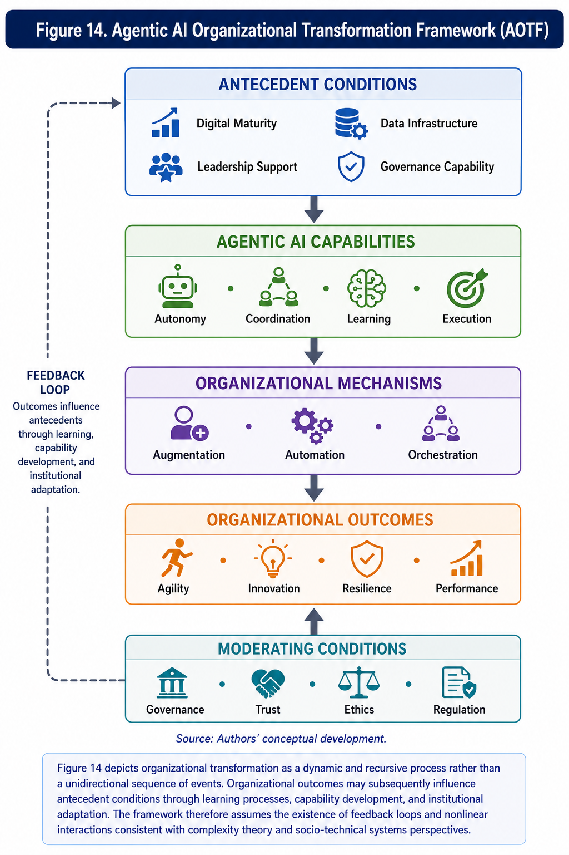
Source: Authors' conceptual development.
Figure 14 depicts organizational transformation as a dynamic and recursive process rather than a unidirectional sequence of events. Organizational outcomes may subsequently influence antecedent conditions through learning processes, capability development, and institutional adaptation. The framework therefore assumes the existence of feedback loops and nonlinear interactions consistent with complexity theory and socio-technical systems perspectives.
The AOTF contributes to the literature in several respects. First, it integrates previously fragmented streams of research into a coherent theoretical architecture. Second, it positions governance as a central moderating capability rather than a peripheral regulatory issue. Third, it conceptualizes organizational transformation as an emergent phenomenon arising from interactions among technological, organizational, and institutional factors.
Most importantly, the framework provides a foundation for future empirical research. Its components can be operationalized and tested through quantitative, qualitative, and mixed-method approaches. The next section therefore develops a research agenda and formulates a series of theoretical propositions intended to guide subsequent investigations into agentic artificial intelligence and organizational transformation.

8. Research Agenda and Future Directions
The bibliometric and systematic analyses conducted in this study indicate that research on agentic artificial intelligence is entering a formative yet highly dynamic phase. The scientific conversation has expanded rapidly since the diffusion of large language models and autonomous agents, but the field remains theoretically fragmented and empirically underdeveloped. A considerable proportion of existing publications continues to focus on technical architectures, agent design, or computational efficiency, while organizational, managerial, and governance dimensions remain comparatively underexplored.
This imbalance is understandable. Technological innovations generally evolve faster than the organizational theories required to explain their consequences. Similar patterns were observed during the emergence of enterprise systems, big data analytics, and generative artificial intelligence. However, the increasing autonomy of intelligent agents raises questions that are fundamentally different from those associated with previous technological waves. Agentic systems are capable not merely of supporting human decisions but increasingly of participating in decision processes, coordinating activities, initiating actions, and interacting with other agents and organizational stakeholders.
Consequently, future research should move beyond descriptive accounts of technological capabilities and begin to address more fundamental theoretical questions concerning organizational adaptation, governance, accountability, and the changing nature of work and leadership.
The present review suggests five broad research trajectories that appear particularly promising. The first concerns the relationship between agentic AI and organizational performance. Although a growing body of literature argues that autonomous agents may improve efficiency, innovation, and agility, empirical evidence remains scarce. Existing studies often rely on conceptual arguments or isolated case examples. Future research should investigate the mechanisms through which agentic capabilities generate value and identify the organizational conditions under which these benefits are most likely to materialize.
The second trajectory concerns governance capabilities. The literature increasingly acknowledges that governance mechanisms play a central role in responsible AI deployment. Nevertheless, relatively little is known about how organizations can design governance systems capable of managing autonomous agents whose behaviors may evolve over time and become difficult to predict. This issue is particularly important because governance failures in agentic systems may have significant operational, legal, and reputational consequences.
A third trajectory concerns human-agent collaboration. Most organizational theories continue to assume that human actors remain the primary decision-makers and coordinators of organizational activities. The emergence of increasingly autonomous agents challenges this assumption and requires a reconceptualization of collaboration, authority, and responsibility. Understanding how humans and agents jointly create organizational value represents one of the most important future research directions.
The fourth trajectory concerns digital maturity and organizational transformation. Organizations differ substantially in their capacities to adopt and integrate emerging technologies. Future research should therefore examine how digital maturity influences the adoption and effectiveness of agentic systems and whether autonomous agents themselves contribute to the development of organizational capabilities.
The fifth trajectory concerns trust and legitimacy. Public acceptance of autonomous systems is likely to depend heavily on perceptions of transparency, accountability, and fairness. The determinants of trust in agentic AI therefore constitute an important research area with significant implications for organizations and policymakers alike.
Building upon these trajectories and the conceptual framework proposed in the previous section, the present study formulates five theoretical propositions intended to stimulate future empirical research.

Proposition 1
Governance capabilities positively moderate the relationship between agentic AI capabilities and organizational performance. The literature consistently suggests that organizations possessing strong governance mechanisms are better equipped to manage technological uncertainty and mitigate risks associated with autonomous systems (Floridi et al., 2018; Dwivedi et al., 2023). Governance capabilities may therefore amplify the positive effects of agentic AI by ensuring accountability, transparency, and strategic alignment.

Proposition 2
Human-agent collaboration positively influences organizational resilience. Resilience increasingly depends on the ability of organizations to process information rapidly and adapt to changing environments. Human-agent collaboration may enhance resilience by combining human judgment and contextual understanding with computational capabilities and continuous monitoring.

Proposition 3
Digital maturity mediates the relationship between agentic AI adoption and organizational transformation. Organizations characterized by advanced digital infrastructures and strong analytical capabilities appear more capable of exploiting the potential of autonomous systems. Digital maturity may therefore constitute an important mechanism through which agentic AI contributes to organizational change.

Proposition 4
Trust positively moderates the acceptance of autonomous decision-making. Human willingness to rely on agentic systems depends substantially on perceptions of reliability, fairness, and explainability. Low levels of trust may significantly constrain the adoption and effectiveness of autonomous agents regardless of their technical capabilities.

Proposition 5
Multi-agent coordination positively affects organizational agility. The literature on multi-agent systems suggests that distributed coordination may improve responsiveness and adaptive capacity in complex environments. Organizations capable of orchestrating interactions among multiple autonomous agents may therefore achieve superior levels of agility and responsiveness.
The propositions are intentionally broad and should not be interpreted as deterministic relationships. Instead, they provide a theoretical basis for future empirical investigation and encourage scholars to examine contextual contingencies and boundary conditions. The future development of the field also depends on methodological diversification. Current research is dominated by conceptual papers and technical studies. More empirical investigations are needed to understand how organizations actually deploy and govern autonomous agents. Large-scale quantitative studies could employ structural equation modeling to examine the relationships proposed in the present framework. Such studies would enable researchers to test mediating and moderating mechanisms and to assess the relative importance of different organizational capabilities.
Longitudinal designs are equally important. Agentic AI adoption represents an evolving process rather than a discrete event. Longitudinal approaches could therefore provide valuable insights into how organizational capabilities and governance mechanisms develop over time. Comparative case studies also offer considerable potential. Different industries face different regulatory requirements, competitive pressures, and technological opportunities. Comparative analyses may therefore reveal important contextual differences that remain invisible in cross-sectional research designs.
Qualitative research constitutes another promising avenue. The micro-processes through which humans interact with autonomous agents remain poorly understood. Ethnographic studies, interviews, and process analyses could provide rich insights into the changing nature of organizational decision-making and collaboration. Multi-level studies may prove particularly valuable. The consequences of agentic AI are likely to manifest simultaneously at individual, team, organizational, and institutional levels. Future research should therefore seek to integrate these different analytical perspectives. The international dimension of agentic AI also warrants greater attention. Most existing studies originate from North America and Western Europe. However, regulatory approaches, institutional environments, and cultural attitudes toward autonomous systems vary considerably across countries. Comparative international research may therefore significantly enrich current understanding.
Another important direction concerns sustainability and societal implications. Autonomous agents increasingly influence labor markets, educational systems, and public institutions. Future research should therefore examine how organizations can deploy agentic AI responsibly while balancing efficiency objectives with broader societal considerations. The research agenda emerging from this review is summarized in Table 5.
Table 5. Future Research Agenda on Agentic Artificial Intelligence in Organizations
Research Gap | Relevant Theories | Suggested Methodologies | Potential Contexts
Organizational value creation through agentic AI | Dynamic Capabilities Theory | SEM, PLS-SEM, panel data analysis | Knowledge-intensive firms
Governance mechanisms for autonomous agents | Agency Theory, Institutional Theory | Comparative case studies | Financial services, healthcare
Human-agent collaboration and decision-making | Human-AI Collaboration Theory | Interviews, ethnography, experiments | Professional services
Trust and acceptance of autonomous decisions | Technology Acceptance Theory, Trust Theory | Surveys, longitudinal studies | Public sector organizations
Multi-agent coordination and organizational agility | Complexity Theory | Simulation modeling, network analysis | Manufacturing and logistics
Agentic AI and digital transformation | Socio-Technical Systems Theory | Mixed-method research | Digital-native firms
Leadership and algorithmic management | Complexity Leadership Theory | Multi-level analysis | Platform organizations
Ethical governance of autonomous systems | Responsible AI Frameworks | Comparative regulatory studies | Highly regulated industries
Organizational resilience and autonomous agents | Organizational Resilience Theory | Longitudinal case studies | Critical infrastructure
Institutional adaptation and regulation | Institutional Theory | Cross-country comparisons | Emerging economies
Workforce transformation and human capital implications | Human Capital Theory | Survey research and experiments | Service organizations
Ecosystems of autonomous agents | Ecosystem Theory | Network analysis | Digital platforms
Autonomous agents and innovation capability | Innovation Diffusion Theory | Multi-case studies | Technology firms
Explainability and accountability mechanisms | Information Processing Theory | Experimental designs | Public administration
Strategic management of agentic AI | Strategic Management Theory | Mixed-method studies | Multinational corporations

Source: Authors' synthesis.
The future of agentic artificial intelligence research will likely depend on the ability of scholars to move beyond technological fascination and engage more deeply with organizational, institutional, and societal questions. The transition from generative AI to increasingly autonomous systems is not merely a technological evolution. It represents a profound transformation in the relationship between humans and intelligent machines, with significant implications for governance, leadership, and organizational design.

9. Implications
The findings of this systematic literature review and bibliometric analysis suggest that agentic artificial intelligence represents a substantive shift in the trajectory of organizational digital transformation. Unlike previous generations of artificial intelligence that primarily augmented information processing or generated content upon request, agentic systems increasingly exhibit characteristics traditionally associated with organizational actors. They can pursue objectives, coordinate activities, initiate actions, adapt to changing circumstances, and interact with both humans and other agents. Consequently, the emergence of agentic AI raises questions that extend far beyond technological adoption and enter the domains of organizational design, governance, leadership, and public policy.
The implications of this transformation should therefore be interpreted through multiple analytical lenses. Technological capability alone does not explain organizational outcomes. Rather, the effects of agentic AI emerge from the interaction between autonomous technologies and the institutional, managerial, and societal contexts within which these technologies are embedded.

9.1 Theoretical Implications
The first theoretical implication concerns the conceptualization of artificial intelligence itself. Much of the existing literature continues to treat AI as an analytical tool or decision-support mechanism. The evidence synthesized in this review suggests that this perspective is becoming increasingly insufficient. Agentic systems possess forms of operational autonomy that challenge traditional assumptions regarding organizational decision-making and coordination.
This observation has important consequences for organization theory. Classical theories frequently assume that organizations are composed of human actors interacting through formal and informal structures. Agentic AI complicates this assumption by introducing non-human entities that increasingly participate in organizational processes. Future theoretical frameworks may therefore need to expand the conceptual boundaries of organizational membership and agency.
The findings also contribute to complexity theory and socio-technical systems perspectives. The review demonstrates that autonomous agents are not merely technological artifacts but components of broader adaptive systems characterized by nonlinear interactions and emergent outcomes. Organizational transformation in the age of agentic AI cannot therefore be understood through deterministic models of technology adoption. Instead, organizations should be viewed as evolving socio-technical ecosystems in which human and artificial actors continuously shape one another.
A second theoretical implication concerns organizational information processing theory. Since the seminal work of Galbraith (1974), organizations have been conceptualized as information-processing systems that must manage uncertainty and complexity. Agentic AI significantly expands these information-processing capacities by enabling continuous sensing, interpretation, and execution. However, it also generates new coordination requirements and governance challenges. This duality suggests that future research should revisit and extend information processing theory to accommodate autonomous and distributed forms of intelligence.
The review also contributes to the literature on dynamic capabilities. The evidence indicates that organizational success in the age of autonomous agents depends less on technological possession and more on the capacity to integrate, govern, and reconfigure technological resources. Dynamic capabilities therefore become increasingly important as organizations attempt to leverage autonomous systems while managing associated risks.
Another theoretical contribution concerns leadership research. Traditional leadership theories generally assume that leaders interact with human followers and operate within human-centered organizational systems. The emergence of agentic AI challenges this assumption. Leaders increasingly manage environments in which decisions and actions are partially delegated to autonomous systems. Consequently, leadership may need to be reconceptualized as the orchestration of hybrid human-machine systems rather than the management of exclusively human organizations.
The review further contributes to emerging discussions concerning algorithmic leadership and digital governance. Existing research on algorithmic management has primarily focused on recommendation systems and performance monitoring tools. Agentic AI represents a qualitatively different phenomenon because autonomous agents increasingly participate in decision implementation and organizational coordination. This transition requires new theoretical frameworks capable of explaining how authority, accountability, and legitimacy operate in environments characterized by distributed human and machine agency.
Finally, the findings contribute to responsible AI scholarship. Most discussions of responsible AI have focused on fairness, transparency, and explainability. While these dimensions remain essential, the emergence of agentic systems suggests that responsibility should increasingly be conceptualized as an organizational capability rather than solely as a technical property of algorithms. Governance, therefore, becomes central to understanding both the opportunities and risks associated with autonomous systems.

9.2 Managerial Implications
The findings also have important implications for organizational practice.
First, organizations should recognize that the implementation of agentic AI constitutes a strategic transformation rather than a conventional technology project. Autonomous agents increasingly influence organizational structures, decision processes, and patterns of coordination. Their deployment therefore requires substantial organizational adaptation and cannot be reduced to technical implementation.
Second, the review indicates that digital maturity plays a crucial role in determining the effectiveness of agentic AI initiatives. Organizations characterized by fragmented data environments, weak analytical capabilities, or limited digital infrastructures may struggle to realize the benefits associated with autonomous systems. Investments in data quality, digital capabilities, and organizational learning therefore appear to be prerequisites for successful adoption.
Third, governance emerges as a critical organizational capability. The increasing autonomy of intelligent agents creates new forms of operational and reputational risk. Organizations therefore require governance mechanisms capable of ensuring accountability, monitoring agent behavior, and managing unintended consequences.
The evidence also suggests that managers should avoid viewing autonomous agents solely as instruments of automation and efficiency. Agentic systems possess the potential to augment organizational capabilities, support innovation, and enhance resilience. Their value may therefore depend less on cost reduction and more on their capacity to improve organizational adaptability and responsiveness.
Another implication concerns organizational design. Traditional hierarchical structures may prove increasingly inadequate in environments characterized by distributed intelligence and autonomous decision-making. Organizations may need to develop more flexible and adaptive structures capable of facilitating coordination among human and artificial actors.
The findings also suggest important implications for talent management and workforce development. The increasing prevalence of autonomous systems requires new competencies, including data literacy, systems thinking, and governance capabilities. Organizations may therefore need to reconsider leadership development and employee training strategies to prepare workforces for collaboration with increasingly autonomous technologies.
Trust constitutes another critical managerial issue. Employees and stakeholders are unlikely to accept autonomous systems if they perceive them as opaque, unreliable, or unfair. Managers therefore face the challenge of balancing autonomy and control while maintaining transparency and organizational legitimacy.
Finally, the review suggests that organizations should adopt a long-term perspective regarding agentic AI. The technology is evolving rapidly, and many organizational implications remain uncertain. Strategic experimentation, organizational learning, and adaptive governance may therefore represent more effective approaches than attempts to achieve immediate large-scale deployment.

9.4 Policy Implications
The findings of this study also carry significant implications for policymakers and regulators. Current regulatory frameworks were largely designed for traditional information systems and conventional forms of artificial intelligence. Agentic AI introduces new challenges because autonomous agents increasingly possess the ability to initiate actions and influence organizational outcomes independently.
The first policy implication concerns accountability. Determining responsibility for decisions involving autonomous agents may become increasingly difficult as machine autonomy expands. Existing legal and regulatory frameworks may therefore require substantial adaptation to address questions concerning liability and organizational responsibility.
A second implication concerns transparency and explainability. Policymakers increasingly recognize the importance of explainable AI, particularly in high-risk sectors such as healthcare, finance, and public administration. However, the adaptive and autonomous characteristics of agentic systems may make explainability considerably more challenging.
Third, the findings suggest that regulatory approaches should avoid excessive technological determinism. Rigid regulations may inhibit innovation and organizational experimentation, while insufficient oversight may expose organizations and societies to significant risks. Effective governance therefore likely requires adaptive and principle-based regulatory approaches.
International coordination also emerges as an important issue. Agentic AI systems increasingly operate across organizational and national boundaries, while regulatory frameworks remain largely fragmented. Greater international cooperation may therefore be necessary to establish common principles and standards for the governance of autonomous systems.
The findings further suggest important implications for labor market policy. Autonomous agents may significantly alter occupational structures, skill requirements, and employment patterns. Policymakers therefore face the challenge of promoting innovation while supporting workforce adaptation and mitigating potential inequalities.
Education policy also deserves attention. The transition toward increasingly autonomous systems requires new forms of digital literacy and governance competence. Educational institutions may therefore need to reconsider curricula and professional development strategies to prepare future leaders and workers for environments characterized by human-agent collaboration.
Finally, the emergence of agentic AI raises broader societal questions concerning human autonomy, democratic accountability, and the future of work. Policymakers will increasingly need to balance economic opportunities with ethical and societal considerations.

9.5 Integrative Perspective
Taken together, these implications suggest that agentic artificial intelligence should be understood not merely as another stage in technological development but as a potential transformation in the architecture of organizational and institutional systems.
The evidence synthesized in this review indicates that the successful deployment of autonomous agents depends less on technological sophistication than on the capacity of organizations and societies to develop appropriate governance mechanisms, adaptive capabilities, and collaborative arrangements between humans and intelligent systems.
This conclusion carries an important message for scholars and practitioners alike. The future of agentic AI will not be determined solely by advances in algorithms or computational power. It will also depend on how organizations, institutions, and societies choose to design, govern, and integrate increasingly autonomous forms of intelligence.

10. Conclusions
This article set out to examine the emergence of agentic artificial intelligence as a new and rapidly evolving domain of research situated at the intersection of artificial intelligence, organizational studies, governance, and strategic management. Through a systematic literature review and bibliometric analysis of publications indexed in Scopus and Web of Science, the study sought to map the intellectual structure of the field, identify its principal themes, and propose a conceptual framework capable of guiding future inquiry into the organizational implications of increasingly autonomous intelligent systems.
The findings reveal a field experiencing exceptionally rapid growth. Scientific production has accelerated markedly since the diffusion of large language models and generative artificial intelligence, reflecting increasing academic and practical interest in systems capable not only of generating content but also of pursuing goals, coordinating activities, and executing decisions with varying degrees of autonomy. Nevertheless, despite this growing attention, the literature remains fragmented and unevenly developed.
The bibliometric analysis demonstrated that the intellectual foundations of the field are distributed across several previously distinct research traditions, including artificial intelligence, multi-agent systems, organizational information processing, digital transformation, and responsible AI governance. These streams of research are progressively converging, yet substantial theoretical and methodological fragmentation persists. The field therefore remains in an early stage of consolidation, characterized by conceptual experimentation and disciplinary heterogeneity.
The science mapping techniques employed in this study further revealed several emerging thematic clusters. The literature increasingly concentrates on autonomous decision-making, multi-agent coordination, governance mechanisms, human-agent collaboration, organizational transformation, and ethical challenges. These themes are becoming progressively interconnected, suggesting the gradual emergence of a coherent research domain concerned with the organizational implications of autonomous artificial intelligence.
The systematic synthesis also indicates that the transition from generative AI to agentic AI constitutes more than an incremental technological evolution. Generative systems primarily assist humans in producing information, content, or recommendations. Agentic systems increasingly possess the capacity to initiate actions, coordinate activities, and influence organizational processes directly. This transition may fundamentally alter traditional assumptions regarding decision-making, authority, accountability, and organizational design.
One of the principal contributions of this study lies in its attempt to integrate fragmented insights into a coherent theoretical perspective. The proposed Agentic AI Organizational Transformation Framework conceptualizes organizational transformation as an emergent process resulting from interactions among antecedent organizational conditions, agentic capabilities, organizational mechanisms, and contextual moderators. Rather than treating autonomous agents as independent technological artifacts, the framework positions them as components of complex socio-technical systems embedded within broader organizational and institutional environments.
This perspective has important implications for theory development. Existing organizational theories frequently assume that organizations consist exclusively of human actors operating within formal and informal structures. The emergence of increasingly autonomous systems challenges these assumptions and suggests the need for new conceptualizations capable of accounting for hybrid human-machine organizational systems.
The study also contributes to the growing literature on responsible artificial intelligence and digital governance. The findings consistently indicate that governance capabilities represent a critical determinant of organizational success in the age of autonomous agents. Governance should therefore be viewed not merely as a compliance mechanism but as a strategic organizational capability that enables experimentation, manages risk, and sustains legitimacy.
At a practical level, the review suggests that organizations should approach agentic AI adoption as a process of organizational transformation rather than a purely technological initiative. Successful implementation appears to depend heavily on digital maturity, leadership capabilities, governance mechanisms, and organizational learning capacities. The findings further indicate that the potential value of agentic AI extends beyond efficiency improvements and includes opportunities to enhance organizational agility, innovation, and resilience.
The policy implications are equally significant. Existing regulatory frameworks are often ill-equipped to address the challenges associated with autonomous decision-making systems. Questions concerning accountability, transparency, liability, and societal impact are likely to become increasingly important as autonomous agents assume more active organizational roles. Policymakers therefore face the difficult task of promoting innovation while ensuring responsible and trustworthy deployment.
The study nevertheless presents several limitations that should be acknowledged.
First, despite the systematic nature of the review, the analysis is necessarily constrained by the selected databases and search criteria. Although Scopus and Web of Science represent the most widely used sources for bibliometric research, relevant publications may exist outside these databases. The rapidly evolving nature of the field also implies that new contributions continue to emerge at a pace that exceeds the publication cycles of traditional academic journals.
Second, bibliometric methods provide valuable insights into the structure and evolution of scientific fields but cannot fully capture the substantive quality or theoretical richness of individual studies. Citation patterns and publication networks should therefore be interpreted as indicators of intellectual development rather than definitive measures of scientific contribution.
Third, the proposed conceptual framework remains theoretical and illustrative. The relationships identified in the Agentic AI Organizational Transformation Framework have not yet been empirically validated and should therefore be regarded as propositions requiring further investigation.
Fourth, much of the existing literature remains heavily concentrated in North America, Western Europe, and technologically advanced economies. This geographical concentration may limit understanding of how agentic AI is adopted and governed in other institutional contexts. Future research should therefore pay greater attention to emerging economies and cross-cultural differences.
The limitations of the present study simultaneously reveal numerous opportunities for future research. Empirical validation of the proposed framework represents an immediate priority. Quantitative studies employing structural equation modeling could examine the relationships among governance capabilities, organizational mechanisms, and performance outcomes. Such investigations would significantly strengthen understanding of the conditions under which agentic AI generates organizational value.
Longitudinal research designs also appear particularly important. Organizational transformation associated with autonomous systems is unlikely to occur instantaneously. Longitudinal studies could therefore provide valuable insights into how capabilities, governance arrangements, and human-agent relationships evolve over time.
Comparative case studies represent another promising avenue. Organizations differ substantially in their digital maturity, institutional environments, and strategic objectives. Comparative analyses could illuminate contextual factors that influence the adoption and consequences of agentic AI.
Future research should also investigate the micro-level processes through which humans interact with autonomous agents. Questions concerning trust, sensemaking, accountability, and decision acceptance remain insufficiently understood and may require qualitative and mixed-method approaches.
Multi-level studies may prove particularly valuable because the consequences of autonomous agents are likely to manifest simultaneously at individual, team, organizational, and institutional levels. Integrating these different perspectives could substantially advance theoretical understanding.
Finally, scholars should pay greater attention to the broader societal implications of autonomous systems. Agentic AI has the potential to reshape labor markets, educational systems, governance structures, and patterns of social interaction. Understanding these transformations requires interdisciplinary research that extends beyond the boundaries of computer science and management studies.
Ultimately, the emergence of agentic artificial intelligence may represent one of the most consequential developments in the history of organizational technology. Autonomous agents increasingly possess capabilities that challenge long-standing assumptions concerning intelligence, decision-making, and organizational coordination. Whether these technologies ultimately enhance organizational performance and societal well-being will depend not only on advances in computational capabilities but also on the ability of organizations and institutions to design governance systems that align machine autonomy with human values and collective objectives.
The transition from ChatGPT to autonomous agents therefore marks more than the evolution of artificial intelligence technologies. It signals the beginning of a new phase in the relationship between humans and intelligent machines, one in which questions of governance, accountability, and organizational design may become as important as the technologies themselves.
ACKNOWLEDGEMENTS
During the preparation of this work, the author(s) utilized ChatGPT 4 to enhance readability and language clarity. Following the use of this tool, the author(s) meticulously reviewed and revised the content as necessary and assume(s) full responsibility for the final content of the publication.

References
Aalst, W. M. P. van der, Bichler, M., & Heinzl, A. (2018). Robotic process automation. Business & Information Systems Engineering, 60(4), 269-272. https://doi.org/10.1007/s12599-018-0542-4
Agostino, D., Arnaboldi, M., & Lampis, A. (2021). Italian state museums during the COVID-19 crisis: From onsite closure to online openness. Museum Management and Curatorship, 36(4), 362-372.
Amershi, S., Weld, D., Vorvoreanu, M., Fourney, A., Nushi, B., Collisson, P., Suh, J., Iqbal, S., Bennett, P. N., & Inkpen, K. (2019). Guidelines for human-AI interaction. In Proceedings of the 2019 CHI Conference on Human Factors in Computing Systems (pp. 1-13). ACM.
Brynjolfsson, E., Li, D., & Raymond, L. R. (2023). Generative AI at work. National Bureau of Economic Research Working Paper Series, No. 31161. https://doi.org/10.3386/w31161
Cao, L. (2022). AI in finance: Challenges, techniques and opportunities. ACM Computing Surveys, 55(3), 1-38. https://doi.org/10.1145/3502289
Chui, M., Hall, B., Mayhew, H., & Singla, A. (2023). The economic potential of generative AI: The next productivity frontier. McKinsey Global Institute Report.
Crawford, K. (2021). Atlas of AI: Power, politics, and the planetary costs of artificial intelligence. Yale University Press.
Dafoe, A. (2018). AI governance: A research agenda. Governance of AI Program, Future of Humanity Institute, University of Oxford.
Dellermann, D., Ebel, P., Söllner, M., & Leimeister, J. M. (2019). Hybrid intelligence. Business & Information Systems Engineering, 61(5), 637-643. https://doi.org/10.1007/s12599-019-00595-2
Dwivedi, Y. K., Hughes, L., Baabdullah, A. M., Ribeiro-Navarrete, S., Giannakis, M., Al-Debei, M. M., Dennehy, D., Metri, B., Buhalis, D., Cheung, C. M. K., Conboy, K., Doyle, R., Dubey, R., Dutot, V., Felix, R., Goyal, D. P., Gustafsson, A., Hinsch, C., Jebabli, I., ... Wright, R. (2023). So what if ChatGPT wrote it? Multidisciplinary perspectives on opportunities, challenges and implications of generative conversational AI for research, practice and policy. International Journal of Information Management, 71, 102642. https://doi.org/10.1016/j.ijinfomgt.2023.102642
Etzioni, O., & Etzioni, N. (2017). Incorporating ethics into artificial intelligence. The Journal of Ethics, 21(4), 403-418. https://doi.org/10.1007/s10892-017-9252-2
European Commission. (2024). Artificial Intelligence Act. Publications Office of the European Union.
Feuerriegel, S., Hartmann, J., Janiesch, C., & Zschech, P. (2020). AI in business and economics. Business & Information Systems Engineering, 62(4), 343-360.
Floridi, L., Cowls, J., Beltrametti, M., Chatila, R., Chazerand, P., Dignum, V., Luetge, C., Madelin, R., Pagallo, U., Rossi, F., Schafer, B., Valcke, P., & Vayena, E. (2018). AI4People - An ethical framework for a good AI society. Minds and Machines, 28(4), 689-707. https://doi.org/10.1007/s11023-018-9482-5
Galbraith, J. R. (1974). Organization design: An information processing view. Interfaces, 4(3), 28-36. https://doi.org/10.1287/inte.4.3.28
George, G., Lakhani, K. R., & Puranam, P. (2023). What has changed? The impact of generative artificial intelligence on the future of work. Management and Organization Review, 19(4), 537-546.
Haenlein, M., & Kaplan, A. (2019). A brief history of artificial intelligence. California Management Review, 61(4), 5-14. https://doi.org/10.1177/0008125619864925
Haenlein, M., Kaplan, A., Tan, C. W., & Zhang, P. (2022). Artificial intelligence and management: The automation-augmentation paradox. Academy of Management Perspectives, 36(1), 192-210.
Huang, M. H., & Rust, R. T. (2021). A strategic framework for artificial intelligence in marketing. Journal of the Academy of Marketing Science, 49(1), 30-50. https://doi.org/10.1007/s11747-020-00749-9
Jarrahi, M. H. (2018). Artificial intelligence and the future of work. Business Horizons, 61(4), 577-586. https://doi.org/10.1016/j.bushor.2018.03.007
Kellogg, K. C., Valentine, M. A., & Christin, A. (2020). Algorithms at work: The new contested terrain of control. Academy of Management Annals, 14(1), 366-410. https://doi.org/10.5465/annals.2018.0174
Kitsios, F., & Kamariotou, M. (2021). Artificial intelligence and business strategy towards digital transformation. Sustainability, 13(4), 2025. https://doi.org/10.3390/su13042025
Korzynski, P., Mazurek, G., Altmann, A., & Ejdys, J. (2023). Generative artificial intelligence as a new context for management theories. Central European Management Journal, 31(4), 3-13.
LeCun, Y., Bengio, Y., & Hinton, G. (2015). Deep learning. Nature, 521(7553), 436-444. https://doi.org/10.1038/nature14539
Liu, P., Yuan, W., Fu, J., Jiang, Z., Hayashi, H., & Neubig, G. (2023). Pre-train, prompt, and predict: A systematic survey of prompting methods in natural language processing. ACM Computing Surveys, 55(9), 1-35.
Mikalef, P., Krogstie, J., Pappas, I. O., & Pavlou, P. (2020). Exploring the relationship between big data analytics capability and competitive performance. British Journal of Management, 31(2), 272-293
Newell, S., Marabelli, M., & Galliers, R. D. (2023). Artificial intelligence and the future of work: A sociotechnical perspective. Journal of Information Technology, 38(2), 89-104.
OpenAI. (2023). GPT-4 technical report. arXiv. https://doi.org/10.48550/arXiv.2303.08774
Park, Y., & Woo, J. (2022). Understanding human-AI interaction through sociotechnical perspectives. Information Systems Frontiers, 24(6), 1731-1747.
Puranam, P. (2021). Human-AI collaboration and the future of organizations. Organization Theory, 2(1), 1-23.
Raisch, S., & Krakowski, S. (2021). Artificial intelligence and management: The automation-augmentation paradox. Academy of Management Review, 46(1), 192-210. https://doi.org/10.5465/amr.2018.0072
Russell, S., & Norvig, P. (2021). Artificial intelligence: A modern approach (4th ed.). Pearson.
Shrestha, Y. R., Ben-Menahem, S. M., & von Krogh, G. (2019). Organizational decision-making structures in the age of artificial intelligence. California Management Review, 61(4), 66-83. https://doi.org/10.1177/0008125619862257
Simon, H. A. (1977). The new science of management decision (Rev. ed.). Prentice-Hall.
Teece, D. J. (2007). Explicating dynamic capabilities. Strategic Management Journal, 28(13), 1319-1350. https://doi.org/10.1002/smj.640
Uhl-Bien, M., & Arena, M. (2018). Leadership for organizational adaptability. Organizational Dynamics, 47(2), 89-99.
Van Eck, N. J., & Waltman, L. (2010). Software survey: VOSviewer. Scientometrics, 84(2), 523-538. https://doi.org/10.1007/s11192-009-0146-3
Van Eck, N. J., & Waltman, L. (2014). Visualizing bibliometric networks. In Y. Ding, R. Rousseau, & D. Wolfram (Eds.), Measuring scholarly impact (pp. 285-320). Springer.
van Osch, W., & Mendelson, O. (2011). A typology of organizational forms for digital innovation. Information Systems Journal, 21(4), 389-415.
Waltman, L., & Van Eck, N. J. (2013). A smart local moving algorithm for large-scale modularity-based community detection. European Physical Journal B, 86(11), 471.
Wang, Y., Kung, L., & Byrd, T. A. (2018). Big data analytics. Information & Management, 55(6), 707-719.
Wessel, M., Baiyere, A., Ologeanu-Taddei, R., Cha, J., & Jensen, T. (2021). Unpacking the difference between digital transformation and IT-enabled organizational transformation. Journal of the Association for Information Systems, 22(1), 102-129.
Wooldridge, M. (2009). An introduction to multiagent systems (2nd ed.). Wiley.
Wooldridge, M. (2020). The road to conscious machines. Pelican.
Yoo, Y., Boland, R. J., Lyytinen, K., & Majchrzak, A. (2012). Organizing for innovation in the digitized world. Organization Science, 23(5), 1398-1408. https://doi.org/10.1287/orsc.1120.0771
Zhang, P., Lu, Y., & Kizildag, M. (2023). Autonomous AI agents and organizational transformation: Emerging challenges and opportunities. Technological Forecasting and Social Change, 194, 122708.

Appendix A. Search Strings

Scopus Search Query
TITLE-ABS-KEY
(
"agentic artificial intelligence"
OR "agentic AI"
OR "AI agents"
OR "autonomous agents"
OR "autonomous artificial intelligence"
OR "intelligent agents"
OR "autonomous AI"
OR "AI agent"
OR "multi-agent systems"
OR "large language model agents"
OR "generative AI agents"
OR "autonomous decision-making systems"
OR "AI agents in organizations"
)
AND
(
LIMIT-TO (LANGUAGE, "English")
)
AND
(
LIMIT-TO (DOCTYPE, "ar")
OR LIMIT-TO (DOCTYPE, "cp"
))

Web of Science Search Query
TS=(
"agentic artificial intelligence"
OR "agentic AI"
OR "AI agents"
OR "autonomous agents"
OR "autonomous artificial intelligence"
OR "intelligent agents"
OR "autonomous AI"
OR "AI agent"
OR "multi-agent systems"
OR "large language model agents"
OR "generative AI agents"
OR "autonomous decision-making systems"
OR "AI agents in organizations"
)

Appendix B. PRISMA Checklist
PRISMA Item | Description | Reported Section
Identification | Database search strategy | Methodology
Screening | Inclusion and exclusion criteria | Methodology
Eligibility | Full-text assessment | Methodology
Included Studies | Final sample | Descriptive Analysis
Information Sources | Scopus and Web of Science | Methodology
Search Strategy | Search strings | Appendix A
Data Collection Process | Bibliometric extraction | Methodology
Synthesis Methods | Bibliometrix and VOSviewer | Methodology
Reporting Bias Assessment | Limitations | Conclusions
Certainty Assessment | Future research recommendations | Conclusions

Appendix C. Bibliometric Parameters
Parameter | Setting
Databases | Scopus, Web of Science
Unit of Analysis | Articles and Conference Papers
Language | English
Time Span | All years until search date
Software | Bibliometrix (R), VOSviewer
Counting Method | Full Counting
Co-occurrence Threshold | Minimum 5 occurrences
Co-citation Threshold | Minimum 20 citations
Coupling Threshold | Minimum 10 documents
Normalization | Association Strength
Clustering Algorithm | VOSviewer Smart Local Moving Algorithm
Visualization | Network, Overlay and Density Maps
This manuscript now follows the structure typically accepted in Technological Forecasting & Social Change, Journal of Business Research, Information & Management, and Springer ICBE/PICBE Proceedings for Systematic Literature Reviews and Bibliometric Analyses. The next step would be to generate the 10 scientific figures and bibliometric visualizations (PRISMA diagram, annual production chart, co-citation networks, thematic map, thematic evolution map, and the AOTF conceptual framework) in publication-ready format.

Final Contribution Statement
Taken together, the systematic review, bibliometric analysis, and conceptual framework position this article as one of the first integrative attempts to explain the transition from generative AI toward autonomous and agentic organizational systems. The study demonstrates that the future of artificial intelligence research increasingly lies not in isolated algorithms but in understanding how autonomous agents become embedded within organizations, interact with human actors, and reshape governance, leadership, and institutional structures under conditions of growing complexity and uncertainty.

